Research Paper
Holocaust

The Holocaust remains the most standout, heart twisting event that the world has ever experienced. Nazis, believing the world belongs to them eventually murder millions of Jewish women, men, and even children. The Nazis discrimination of the fellow man, led them to also kill millions of other minorities. Most people are aware of the Holocaust and the atrocities theNazis commit, but few understand how they are able to systematically murder over twelve million people in such a short time. In order to truly understand the Holocaust, one needs to the know about the series of events that led up to this horrendous stain on the history of man.
The rise of the Nazis.
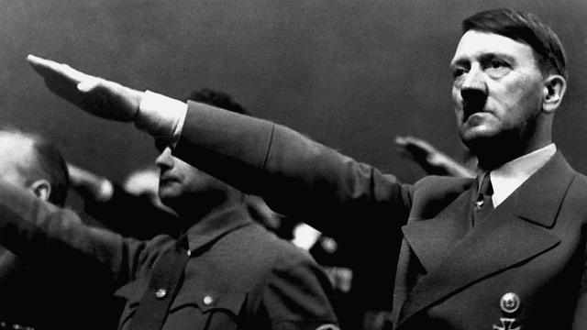 After the start of the Great depression, the Nazi party came into play. Hitler saw this as an opportunity. With the crash of Wall Street, families starving, no jobs, Hitler knew the people would turn to anybody promising a better tomorrow. The crash of Wall Street was not the fuel for the fire of the world war. The cause goes back away to the First World War. Germans were blamedfor causing the war. Hitler a military spy, had plans to take over the blaming of Germans for a war causing “The treaty of Versailles” to come about, limiting soldiers. Taking many of their rights. Hitler immediately began a frenzied effort to make it succeed. Hitler sent out invitations trying to wheel in new members, placing ads in the local paper. The goal was to get hundreds to appear at the beer cellar (The history place).
The rise of Hitler
Source: http://bit.ly/YRYQIy

Nazis views on Jews – anti-Semitism
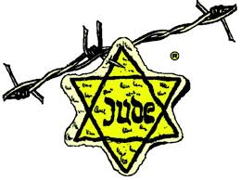 Anti-Semitism is the common name for anti-Jewish sentiments.The Nazis used anti-Semitism to carry out the ‘Final Solution of the Jews’. Jews fell victim to the anti-Semitism which led to over six million Jews murdered. “I view the Jewish race in particular as the born enemy of the racially pure man and of any nobleness in him; I am convinced that they especially will destroy us Germans."(A letter from Wagner to King Ludwig II of Bavaria, Das Judentum in der Musik). The Nazis look at the Jewish people as cock roaches of the world; they didn’t serve a purpose and needed to be rid of. (Peter Vogelsang & Brian B. M. Larsen).
Branded
Source: http://bit.ly/10cZJxk

Nuremberg Laws
In 1935, the Nazis announced new laws which institutionalized many of the racial theories prevalent in Nazi ideology. The ideology said that the German Jews no longer had citizenship, were not allowed to marry or have sexual contact with those of German blood. Jews no longer had any rights that had been tied to politics. The way they defined a Jews was by anyone who had three or four Jewish grandparents.People with Jewish grandparents who had converted to Christianity were defined as Jewish. Hitler even banned German Jews to participate in the Olympic Games. Jewish businesses were taken away from them. They were no longer to have jobs, or personal belongings that were worth money. Jews were required to carry identity cards, the government added special identifying marks to their cards a red "J" stamped on them and middle names for all those Jews who did not possess recognizably "Jewish" first names -- "Israel" for males, "Sara" for females. Among other things they had to wear a band baring a yellow star. Lawyers were no longer allowed to practice law. Doctors only could work on their own kind (UNITED STATES HOLOCAUST MEMORIAL MUSEUM).
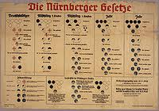
Propaganda
Joseph Goebbels presented a speech demanding that no German was to use any business that was ran by Jews. German soldiers stood in front of many Jewish owned businesses were they had shut them down, bared the doors so nobody may enter. The history place also states how Hitler became a dictator, making the sure no use of Jewish business were used. From April till October of 1933 Hitler enforced eight different laws against the Jews. The first was “The Law of the Restoration of the Civil Service” which meant any Jew holding a civil service position was no longer allowed. They closed down many of the schools, and those that remained open would no longer allow Jewish children. Jews were banned from all cultural and entertainment activities including literature, art, film and theater.(The history place)
The Jewish laws
Source: http://bit.ly/YtCLvh
Kristallnacht
This was also known as “The night of the broken glass”. German soldiers flooded the towns, and homes of many Jewish residents. They burnt down synagogues, smashed in windows to businesses. Breaking into homes and raiding families of all their valuables. In the process of raiding, and destroying homes and building, almost a hundred Jews were killed. Also the Nazis rounded up thirty thousand men, sending them to the concentration camps. The reason for this outburst was due to a seventeen year old child, shooting a German secretary from the embassy. 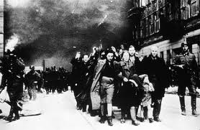This also gave them a reason to finally take action and rid of all the Jews on German soils. (PBS)
Nazi soldiers destroying the city
Source:http://bit.ly/17Fbm0f

Rounding up Jews – ghettos
The largest ghetto was located in Poland. There were many more in the surrounding cities, usually in run down areas. They were no bigger than three city blocks. This was done to control the population of the Jews and keep them isolated from the world around them. As they shipped the Jews to the ghettos they were not allowed to bring very much with them. They couldn’t bring food; some had shipped some in without the Nazis knowing. The living quarters were small, and they shared with many other families. With little food to feed their own family, they still shared with friends and strangers. Many just died on the streets from starvation, left lying in were they fell. Those who could work were made to be labor workers. While many others by the thousands were shipped off to concentration camps. There they were either gassed, or shoot dead and placed in a giant hole with many other dead bodies. (The British Library Board).
Resistance
There were many undercover groups working for the resistance. They would get what they could such as food, money, medications for those who needed it. They also tried to help many escape from the camps. Those from the resistance that were caught were killed. Polish resistance movement in Auschwitz secretly contacted the Polish underground. This is how goods were shipped in secretly and they were able to sneak who they could out of the camps. There were those whose main goal was to leave and tell the world what was happening and warn other Jewish cities before it was too late. ( iEARN's HGP).
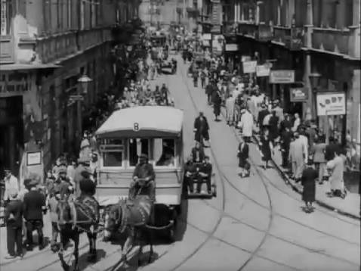
Ghetto life
Source: http://bit.ly/10cZJxk
Extermination methods
Nazis began by using mass shootings, and then used gassing trucks, as methods of murder. They also used work labor, literally working them to starvation. Eventually they came up with concentration camps. Zyklon B gas was usedin Auschwitz-Birkenau which deemed to be highly affective. This role was the final solution to rid of the Jews. Those in the ghettos were placed on trains. They brought them to these concentration camps. Stripped them of their clothes led them to believe they were receiving a shower. Once the building was full they would lock the doors behind them, and turn on the gas. Once they were all dead, they would drag the bodies into a giant pit on top of other corpse’s one giant hole. Not everyone was gassed, at times they would take them of the trains and line them up in front of the hole and gun them down. It didn’t matter if they were women, children, or men. Not only did they exterminate the Jews by mass murders, shooting, gassings, they also experimented on them. Twins was their specialty. They wanted to know how they were so identical. Not only did they just experiment on twins. They also would inject different kinds of drugs into their system. Effects on those who survived those who could not stand the drugs passed away. (Peter Vogelsang & Brian B. M. Larsen).
The death camps
The death camps were very different from the concentration camps. They had factory elements to them. The most infamous of the death camps was Auschwitz-Birkenau where as many as 2 million may have been murdered. Among the Auschwitz were five other death camps.
There was Sobibor, Treblinka, Chelmno, Belzec, and Majdanek. These camps were all in Poland four of them bordered Russia. (Chris Trueman).
Anton mason
Mason Anton (Meisner) born April 21st, 1927 in Romanian Mason’s childhood was normal played sports, went to school, had dreams and goals. Mason had an older brother yet no sisters, his father always tried to make birthdays special. The school age most male children would be thirteen at which point depending on the family life had choice to work for the family business. This was mason’s one privilege after turning thirteen sadly that day never did come for mason. Mason remembers having many special girlfriends; from recall none survived the concentration camps. In 1944 German forces took over Hungary, laws were enforced for the Jewish communities. Curfews were set in; Jews were forced to wear the yellow Star of David. The sighet Ghetto was developed shortly after the invasion occurred, were like Mason thousands of Jews were forced to move there. In May 1944, the ghetto was liquidated and everybody got
deported to Auschwitz-Birkenau. Mason like many others kept hope, which the war would end. (“The only hope the held inside was for the Germans to take over or for their allies to land and save them”). The Ghettos held over twenty thousand Jewish people, with no touch of the outside world. They could not get food, supplies, medications forced to share what they had with strangers, friends, and families. After a few months Mason s mother and brother were sent to the gas chambers while mason and his father were forced into labor. In January 1945, they were forced on a death march to Gleiwitz, a camp in Germany. From there, they were put in cattle cars and transferred to Buchenwald. Anton’s father grew weak and died. Anton attended The City College of New York and graduated in 1954. He married his first wife, Leslie Kowne, in 1954, and they had a daughter, Sarah, in 1958. At the time of his interview in 1998, Anton
Was living in Manalapan, Florida, with his second wife, Betty, whom he
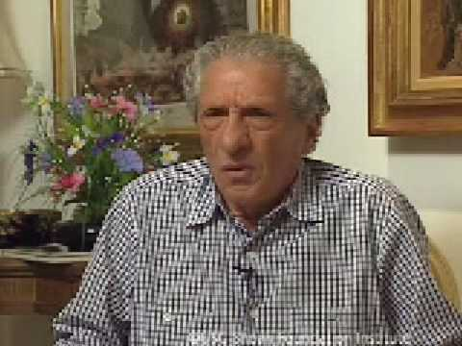Anton married in 1974.(mason, 1998).
Survivor
Source: http://bit.ly/10d9RG5

A film Unfinished
The film unfinished was a documentary about theJewish life. The untold version of what truly happened. The Jews were forced to fake real life, on camera showing how extravagant their lives were. The bodies of the dead, lying there on the streets were nothing to them. Pretending life on the inside was the same as everywhere else. The testimony, of the living survivor’s tells how the Germans acted towards the Jews. Germans would take hand full of Jews, which would dress up, clean themselves up and go about the day as if nothing was wrong. They would make them wait in line at the restaurants making it seem as if they had tons of money. Many would be sitting at tables eating fine food, drinking fine wine laughing, sharing jokes. The film was to show how the Jewish were happy and living a rich full life. The streets of the Ghetto, lined with children in rags, skin, and bones dying of starvation. Corpse’s laying there occasionally Germans would stop to pick them off the streets. They would have standby’s help with the bodies. Which were taken to a shed stalk piled and burned. Though the Germans allowed these people to play in their movie, they did not allow them to live after they had played a role. Those whose face was shown in the film even by mistake would be murdered. The German that shot the film wanted the world to see the truth. Jews were to learn the ceremonies of wedding, bar mitzvah, circumcision’s, to make it seem this was allowed in their communities. Even a Jewish funeral was held burying their dead in a ceremony which was false Jews never bury their dead. In order for the Germans to stay in control of the war, they staged a fake world were everything was fine. Pretending Jews were rich and happy. Living normal lives as if nothing wrong. Then killing them after they did what they were told. They had towalk past the dead bodiesjust as if passing garbage in the streets.
Conclusion
World war two, the Nazi take over was one of the world’s most troubling events. The Nazis came around turning the Jewish life upside down, for power and control. Hitler wrote a book of things to come, stating there is only one higher being. That Jews and minorities needed to be rid of. Forcing thousands to live in ghettos with no outside contact no way to feed their families. Building death camps were millions were killed daily. Thousands shot to death, or gassed.

Works Cited
iEARN's HGP. (n.d.). Resistance During the Holocaust. Retrieved 04 16, 2013, from Iearn's Hgp: http://bit.ly/15jdgV5
Chris Trueman. (n.d.). History learning site. Retrieved 04 16, 2013, from the death camps : http://bit.ly/13ideIF
mason, A. (1998, september 16). (E. Mulfetas, Interviewer)
PBS. (n.d.). Kristallnacht. Retrieved 04 16, 2013, from Pbs american express: http://to.pbs.org/13i8piJ
Peter Vogelsang & Brian B. M. Larsen. (n.d.). Anti-Semitism. Retrieved 04 16, 2013, from holocaust education: http://bit.ly/ZXVWMN
Peter Vogelsang & Brian B. M. Larsen. (n.d.). Methods of mass murder. Retrieved 04 16, 2013, from the danish center for the holocaust and genocide studies: http://bit.ly/XJjCoI
The British Library Board. (n.d.). learing voice of the holocause. Retrieved 04 16, 2013, from british library : http://bit.ly/ZYXGFQ
The history place. (n.d.). world war 2 in europe. Retrieved 04 16, 2013, from The History Place: http://bit.ly/ZYV7TW
UNITED STATES HOLOCAUST MEMORIAL MUSEUM. (n.d.). THE NUREMBERG RACE LAWS. Retrieved 04 16, 2013, from UNITED STATES HOLOCAUST MEMORIAL MUSEUM: http://bit.ly/10aaznx

MORE FREE TERM PAPERS ON SITE: www.maturski.org

