Research Paper

Rounding Up Jews - Ghettos
The Holocaust Describes the Time When the Nazis Come to Power and Try to Massacre Every Jew. For the Jews Who Live During That Time, The Holocaust Is a Word That Comes with Horrible and Cruel Deaths. The Holocaust Keeps a Meaning That Can Never Be Changed or Forgotten by Anyone at Who Understands What the Nazis Did to the Jews. In General Terms, Holocaust Means Burning a Large Amount of Something. The Systematic Murder of Over Twelve Million Innocence People Only Occurred Because of a Series of Events That Takes Place While the Nazis Are in Power. One of Those Nature Events Occurs with the Creation of Hundreds of Ghettos in Poland That Served As Holding Pens While the Nazis Determine a Final Solution to the Jewish Question. The Ghetto Is a Name Describes Where the Jews Were Controlled As Prisoners While Waiting for Transporting to Another Place or Concentration Camps.
According to the Holocaust Education & Archive Research Team, The Term Ghetto Is Not

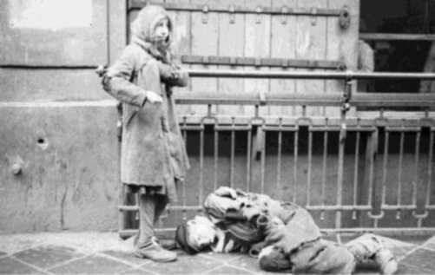
Life in the Warsaw ghetto http://bit.ly/ZpnyhZX
Originated As a Nazi Invention: "Its Origins Can Be Traced

Back to Medieval Times, When Restrictions On the Places

Where Jews Were Allowed to Reside Were Commonplace

Throughout Europe. Although This Restriction Is Usually

Perceived As Relating to Towns or Cities, It Even Applied In

Certain Cases to Entire Countries" (The Ghettos of The

holocaust). Moreover, The Confining Jews in Ghettos Was Not Hitler's Brainchild. According to A
Teacher's Guide to the Holocaust, (Wiesel)
For Centuries, Jews Had Faced Persecution, And Were Often Forced to Live in Designated Areas Called Ghettos. The Nazis' Ghettos Differed, However, In That They Were a Preliminary Step in the Annihilation of the Jews, Rather Than a Method to Just Isolate Them From the Rest of Society. As the War Against the Jews Progressed, The Ghettos Became Transition Areas, Used As Collection Points for Deportation to Death Camps and Concentration Camps. (The Ghettos)
During the First Days When the Nazi Rule Spread Into Other Countries Where Jews Were

living, They Were Nice and Kind to Everyone. According to Author Wiesel, German Soldiers—with Their Steel Helmets and Their Death's-Head Emblem. Still, Our First Impressions of the Germans Were Rather

reassuring. The Officers Were Billeted in Private
Homes, Even in Jewish Homes. Their Attitude Toward Their Hosts Was Distant but Polite. They Never Demanded the Impossible, Made No Offensive Remarks, And Sometimes Even Smiled at the Lady of the House. (34)
However, That Did Not Last Long. After Seven to Eight Days, Things Started to Change. According to Wiesel, The Local Police Burst Into Jews' Homes and Took Every Valuable Thing They Could Find. A Few Days Later, Jews Had to Wear the Yellow Star to Show Everyone That They Were Jews. Moreover, Jews Were Not Allowed to Leave Their Houses at Certain Times, Were Not Allowed to Go to Synagogue, After Some Days, Were Asked to Live in the Ghettos (35-36).
Some Ghettos Existed for Only a Few Days, Others for Months or Years. According to Holocaust Education & Archive Research Team, Not Every Town Had a Ghetto. Reinhard Heydrich's Strategy Was to Join Jews From Small Villages and Towns Together Into a Larger City. Hundreds of Ghettos Were Established in Nazi Occupied Europe, Ranging in Size From the 445,000 Inhabitants of the Warsaw Ghetto to Those Containing Just a Few Families in Rural Quasi-Ghettos (The Ghettos of the Holocaust).
According to United States Holocaust Memorial Museum, The Warsaw Ghetto Was The
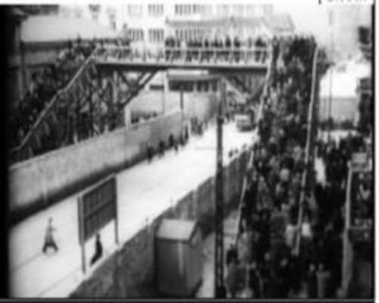
http://bit.ly/17dcmFNX
Largest One in Poland with More Than 445,000 Jews Lived

In an Area of 1.3 Square Miles (Ghettos); In October 1940,

The Germans Ordered the Establishment of a Ghetto In

Warsaw. All Jewish Residents Were Ordered Into The

Designated Area, Which Was Sealed Off by a Wall That Was

a Bridge Connected Areas of the Warsaw Ghetto Over 10 Feet High, Topped with Barbed Wire, And Closely
Guarded to Prevent Movement Between the Ghetto and the Rest of Warsaw (Map). To Easy Control, The Germans Ordered Jews Residing in Ghettos to Wear Identifying Badges or Armbands and Also Required Many Jews to Perform Forced Labor for the German Reich (Ghettos).
According to United States Holocaust Memorial Museum, "In the Early Months of the Ghetto, Life Had the Appearance of Normalcy, But the Lack of Food and Adequate Housing Began to Take It's Toll" (Historical Film Footage). As a Consequence of Racialism, Yael Hersonski Had Shown That the Jews Were Forced to Live in the Ghettos Where Were Full of Restrictions, Laws and Poor Quality. For Example, Hersonski States "2. 8 Kilograms Flour Per Head, 0.199 Kilogram Sugar (White and Yellow) Per Head, 1/5 Egg Per Head, 0.93 Kilogram Fresh Vegetables Per Head, 0.077
Kilogram Salt (White and Grey) Per Head;" Hungers Walked Around Like Moving Skeletons and Lied Everywhere On the Street. Dead Bodies Were Collected Into Big Piles and Buried with Many Layers.
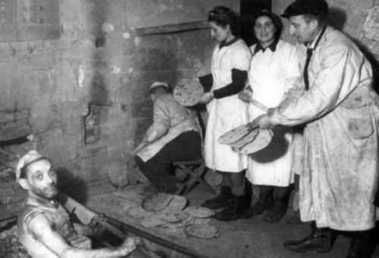
However, Jews Who Were Able to Live in a Better Condition Tried Not to Give Up Their Humanity; Some People Tried to Smuggle Food Into the Ghetto but They Would Be Shot If They Were Caught in the Act of Smuggling Food (A Film Unfinished). Moreover, According to United States
Holocaust Memorial Museum, "Throughout Occupied Poland, Hundreds of Clandestine Schools and Classes Were Organized Inside the Ghettos. Going to and From Class in Various Apartments and Basements, Students Hid Their Books Under Their Clothing. Jews Smuggled Books And
manuscripts Into Many Ghettos for Safekeeping, And
Opened Underground Libraries in Numerous Ghettos." In Addition, The Article Shows That the Jews Also Tried to Keep Religious Activities Such As "So Many Jews Prayed and Held Ceremonies in Secret--In Cellars, Attics, And Back Rooms--As Others Stood Guard. In Warsaw Alone, In 1940, 600 Jewish Prayer Groups Existed (Spiritual Resistance in the Ghettos).
In the Act of the Rounding Jews, The Local Polices Were the One Who Did All That. According to United States Holocaust Memorial Museum,
A Ghetto Police Force Enforced the Orders of the German Authorities and the Ordinances of the Jewish Councils, Including the Facilitation of Deportations to Killing Centers. Jewish Police Officials, Like Jewish Council Members, Served at the Whim of the German Authorities. The Germans Did Not Hesitate to Kill Jewish Policemen Who Were Perceived to Have Failed to Carry Out Orders (Ghettos.)
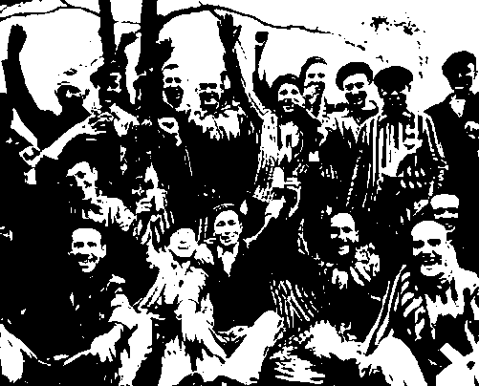
As a Result of Living in the Prisoner Condition, "Deliberately Exacerbated by German Policies, Worsened Over Time. In 1941, One Year Before Mass Deportations, Over 43,000 People Died, More Than 10 Percent of the Entire Ghetto Population" (Deportations to and From the Warsaw Ghetto). As an Evident Truth, Uprising Was to Happen. According to United States Holocaust Memorial Museum, "... Several Jewish Underground Organizations Created an Armed Self-Defense Unit Known As the Jewish Combat Organization" (Warsaw Ghetto Uprising). In Addition to That,
The German Forces Intended to Begin the Operation to Liquidate the Warsaw Ghetto On April 19, 1943, The Eve of Passover. When Ss and Police Units Entered the Ghetto That Morning, The Streets Were Deserted. Nearly All of the Residents of the Ghetto Had Gone Into Hiding Places or Bunkers. The Renewal of Deportations Was the Signal for an Armed Uprising
Celebrating
In General, Ghetto Was a Word That Brought Horrifying and Frightening to the Jews. However, According to Holocaust Education & Archive Research Team, "The Term 'Ghetto' Has Obtained a New Meaning. It Is No Longer a Word That Used Only for the Jews; It Contains a Different Meaning Which Represents Any Ethnic Minority Residing Near to Each Other in a Specific Area of a City Create What Is Often Described As a 'Ghetto'"(The Ghettos of the Holocaust).
Works Cited
A Film Unfinished. Dir. Yael Hersonski. Prods. Itay Ken-Tor and Noemi Schory. 2010. Dvd. Deportations to and From the Warsaw Ghetto. 11 May 2012. Holocaust Encyclopedia. Web. 1 Apr 2013.
Ghettos. 11 May 2012. Holocaust Encyclopedia. Web. 01 Apr 2013.
Historical Film Footage. 1942. National Center for Jewish Film. 11 Apr 2013.
Hoenig, Leonard J., Tomas Spenser and Anita Tarsi. "Reminiscence Dr Karel Fleischmann: The
Story of an Artist and Physician in Ghetto Terezin." International Journal Of
Dermatology 43.2 (2004): 129-135. 1 Apr 2013. Map. N.D. Holocaust Encyclopedia . 03 Apr 2013.
Spiritual Resistance in the Ghettos. 11 May 2012. Holocaust Encyclopedia . Web. 1 Apr 2103. The Ghetto of the Holocaust. 2006. Bjf H.E.A.R.T. Web. 1 Apr 2013.
The Ghettos. 2005. Florida Center for Instructional Technology,College of Education, University
Of South Florida. Web. 1 Apr 2013. Warsaw Ghetto Uprising. 11 May 2012. Holocaust Encyclopedia . Web. 1 Apr 2103.
Wiesel, Elie. Night. New York: Hill and Wang, 2006. Print.

More Free Term Papers On Site: Www.Maturski.Org

