Term Paper
Of
Operation Management
Topic,

More Free Term Papers On Site: Www.Maturski.Org

Index
- Introduction

- Product Range

- Transformational Process Viz Inputs,Outputs and Process Followed in Conversion

- Facility Layout

- Facility Location

- Production Planning System Viz Capacity Planning Operation Management Sheduling Etc.

- Inventory Management

- Model of Supply Chain Management Being Following

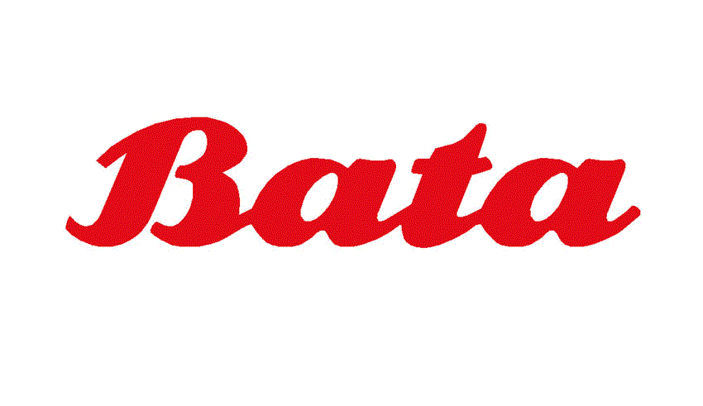

Brief History of the Company
The Business That Became the Bata Shoe Organization Was Established On August 24, 1894 In Zlin, Czechoslovakia by Tomas Bata, And Included His Brother Antonin and Sister Anna. Although This Business Was New, The Bata Name Had Been Part of a Tradition of Shoemaking for Eight Generations, Spanning Three Hundred Years.
It Was One of the First Modern Day Shoe ‘manufacturers’ , A Team of Snitchers and Shoemakers Creating Footwear Not Just for the Local Town , But Also for the Distant Retail Merchants. This Departure From the Centuries Old Tradition of the One Man Cobbler’s Workshop Was a Brand New Concept, Creating an Entirely New Industry.
The Bata Enterprise Revolutionized the Treatment of Employees and Labor Conditions. Tomas Consistently Maintained a Human Focus, Creating Opportunities for Development and Advancement, And Added Compensation for Employees Based On Achievement.
In Late 1985. Antonin Was Drafted Into the Army for Compulsory Military Service and Lift Family Shoe Business. Also That Year, Anna Left the Company to Marry, Leaving a Young Tomas to Build the Business On His Own.
By 1905 Tomas Had Taken the New Enterprise to 2200 Pairs of Shoes Per Day , Produced by 250 Employees – Utilizing Resourceful Imaginations , Skilled Hands and Modern Machinery to Keep Up with Demand. Under This ‘manufacturing’ System, Productivity Was Greater Than Even Before.
Bata Shoes Were Excellent Quality and Available in More Styles Than Had Been Offered Before. Demand Grew Rapidly in the Early 1900s. Despite Material and Manpower Shortages, Cartel and the Outbreak of World War 1, Sales Continued to Increase, Reaching Two Million Pairs Per Year by 1917.
As the Enterprise Prospered, So Did the Communities Where It Operated, Tomas Believed That a Focus On People and Public Service Was Critical for Business Success. The Enterprise Built Housing, Schools and a Hospital Near the Shoemaking Plant in Zlin. It Provided Food and Inexpensive Rent During Very Difficult Times; When There Was No Help to Be Found. Bata Companies Alter Provided Rail Services, Construction, Insurance, Publishing and Tannery in Zlin.
Following World War 1, Consumer Purchasing Power Was Very Low; Tomas and His Employees Devised a Plan to Adjust to Post-War Economic Difficulties and Reduced Their Shoe Prices. Bata Stores Were Flooded with Buyers and Industry Cynics Were Forced to Follow Their Lead.
Already Exporting to Other European Countries, Northern Africa and the USA, The Enterprise Began Establishing New Sales Organizations in These Markets During the 1920s. Companies Were Opened in Poland, Yugoslavia, Holland, Denmark, United Kingdom and the USA. By the Early 1930s, The Bata Enterprise and Czechoslovakia Were the World’s Leading Footwear Exporters.
“the Bata System” Devised by the Zlin Team, And Later Applied in Other Bata Show Organization Companies, Organized Operations Into Autonomous Workshops and Departments, Allowing Employees to Contribute Ideas and Stimulate Production, And Contributed Significant Breakthroughs in Footwear Technology.
Bata India
Bata India Limited

Bata India Managing Director Marcelo Villagran.

Incorporated As Bata Shoe Company Private Limited in 1931, The Company Was Set Up Initially As a Small Operation in Konnagar (Near Calcutta) In1932. In January 1934, The Foundation Stone for the First Building of Bata's Operation - Now Called the Bata. In the Years That Followed, The Overall Site Was Doubled in Area. This Township Is Popularly Known As Batanagar. It Was Also the First Manufacturing Facility in the Indian Shoe Industry to Receive the Iso: 9001 Certification.The Company Went Public in 1973 When It Changed It's Name to Bataindia Limited. Today, Bata India has Established Itself As India's Largest Footwear Retailer. It's Retail Network of 1250 Stores Gives It a Reach/ Coverage That No Other Footwear Company Can Match. Thestores Are Present in Good
Locations and Can Be Found in All the Metros, Mini-Metros and Towns Bata's Smart Looking New Stores Supported by a Range of Better Quality Products Are Aimed at Offering a Superior Shopping Experience to It's Customers. And the New Face of Bata India Is Now Visible to the Industry As Well As It's Customers. Today, Backed by a Brand Perception of Experience, The Company Is Working Towards Positioning Itself As a Vibrant and Contemporary Young Brand. It has Significantly Transformed It's Retail Formats to Become More Lifestyle-Oriented, Which has Helped Change Consumer Perceptions to a Large Extent.
Bata India - Today
• σελλσ Οϖερ 45 Μιλλιον Παιρσ οφ Φοοτωεαρ Εϖερψ Ψεαρ
• σερϖεσ Οϖερ 120,000 Χυστομερσ Εϖερψ Δαψ
• σελλσ Τηρουγη Οϖερ 1200 Ρεταιλ Στορεσ
• οπερατεσ 5 Μανυφαχτυρινγ Φαχιλιτιεσ
• εμπλοψσ Μορε Τηαν 6800 Πεοπλε

Bata’s Business Units
- Bata Europe, Lausanne
- Bata Asia Pacific-Africa, Singapore
- Bata Latin America, Mexico
- Bata North America, Toronto

Bata Is One of the World Leading Footwear Retailer and Manufacturer with Operations Across 5 Continents Managed by 4 Regional Meaningful Business Units (Mbus). The Mbu Approach provides Quality Resources and Support in Key Areas to the Companies Operating in Similar Markets Such As Product Development, Sourcing or Marketing Support. Each Mbu Is Entrepreneurial in Nature, And can Quickly Adapt to Changes in the Market Place and Seize Potential Growth Opportunities.
bata's Strength Lies in It's Worldwide Presence. While Local Companies Are Self-Governing, Each One Benefits From It's Link to the International Organization for Back-Office Systems, Product Innovations and Sourcing.
although Bata Operates in a Wide Variety of Markets, Climates and Buying Power Bata Companies Share the Same Leadership Points. Two Important Ones Are Product Concept Development and Constant Improvement of Business processes in Order to Offer Customers Great Value and the Best Possible Service.

Vision
To Grow As a Dynamic, Innovative and Market Driven Domestic Manufacturer and Distributor, With Footwear As Our Core Business, While Maintaining a Commitment to the Country, Culture and Environment in Which We Operate

Mission
To Be Successful As the Most Dynamic, Flexible and Market Responsive Organization, With Footwear As It's Core Business

Bata Business
Bata Shoe Organization Companies Are Involved in Every Face of the Business of Shoes. Throughout the World, Bata Companies Service Customers From the Store Sales Floor to the Factory Floor.
Product Range
Brand Of Bata

Marie Claire

Hush Puppies

Power

Bubble Gummers

North Star

Scholl

Weinbrenner
Product Range Starts of Bata 299-2499. Bata Start Range 299 To Lowest Range of School Shoe and Highest Brands of Power & Other Product. Bata Product Lowest to Highest Range Available to Market.
Hush Puppies – Now in India
hush Puppies Are a Famous Shoe Brand of the USA. It Is so Famous and Pioneering That It’s Sometimes Referred to As a Legend. This Brand Is Owned and Operated As a Division by the Wolverine...

Bata Is Worst Shoe Maker
bata Is the People Who Make Shoes for High Prices but with Low Quality. I Bought a Pair of Slippers From Bata Named "Comfit" For Rs. 749/- On May 2007. It Is Not Compfortable at All. The Slipper Is Made...
Poor Quality Shoes
i Bought One Pair of Leather Shoes From Bata, Cochin Dealer Near Padma Junction One Year Before. The Product Was Formal Shoes with Laces. The Shoes Cost Inr 1499 For Me.
Bata Is Worst Shoe Maker
bata Is the People Who Make Shoes for High Prices but with Low Quality. I Bought a Pair of Slippers From Bata Named "Comfit" For Rs. 749/- On May 2007.
High Price Poorest Quality
i Just Happened to Buy Bata Shoes a Week Back. The Item I Bought Was Obviously Overpriced, But Going by the Name Bata I Bought It at 499. Within a Weeks’ Usage, The Shoe Sole Was Partially Ripped Off!

.Transformational Process Viz Inputs Outputs and Process Followed in Conversion.

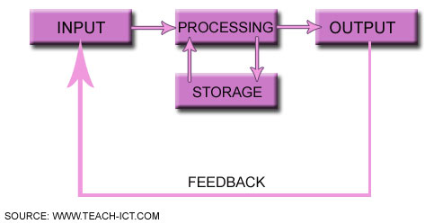
In Order to Handle the Increasing Complexity of Distributed Industrial Manufacturing Systems, There Is a Strong Demand for Methods and Tools That Support the Designer in the Analysis and Optimisation of Flexible Infrastructures for the Automation of Production Processes. We Are Currently Investigating How Emerging Standards and Advanced Simulation Techniques Can Be Exploited Successfully in the Production of Custom Made Shoes.
Nowadays, Many Different Approaches, Methodologies and Computer Aided Design Tools Can Be Employed in the Analysis and Optimization of Complex Industrial Systems. As a Consequence, The Selection of the Most Appropriate Techniques and Tools for a Particular System Is Critical. Before Making Any Final Decision, It Is Necessary to Investigate the Functionalities Offered, Compliancy with Existing Standards, And Capacity for Interoperability with Non-Proprietary Instruments. We Are Currently Working On a Methodological Approach to the Structured Design and Simulation-Based Analysis and Optimisation of Manufacturing Plants. The Methods and Tools Used During the Different Phases of the Design Are Illustrated with Reference to an Application in the Shoe Manufacturing Sector. In Particular, We Describe an Innovative Plant for the Production of Customized Shoes. This Plant Is Located at the Itia-Cnr Laboratory in Vigevano (Italy) And Constitutes the Pilot Plant of a Large European Research Project Called Euroshoe, Which Began in March 2001 And Is Scheduled to Finish in June 2004.

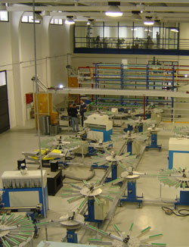
Figure 1: The Innovative Shoe Manufacturing Plant
Euro Shoe Is a Complex and Ambitious Project with Thirty-Five Academic and Industrial Partners From Ten Different European Countries. It Aims at a Dramatic Renovation of the Concept of Shoes As Products and of Their Production, Based On a Transformation From Mass-Produced to Mass-Customised Goods. This Product Evolution Goes in Parallel with a Transformation of Footwear Companies Into Distributed and Flexible Enterprises Capable of Handling the Complexity That Such a Radical Change in the Nature of the Product Implies and of Mastering the Associated New Technological Challenges. This Implies a Complete Revision Not Only of the Entire Manufacturing Process but Also of the Tools Used to Analyse and Optimize the Resulting Innovative Industrial System.
For the Sake of Brevity, The Methods and Tools Used for the Design, Analysis and Optimization of the Plant Automation System Are Outlined with Reference to the Control and Supervision of the Transport Line. In the Shoe Manufacturing Plant That We Consider (Figure 1), An Innovative Transport Line Is Used to Move the Semi-Finished Shoes From One Machining Station to Another According to a Predefined Operating Schedule. In Particular, The Innovative Molecular Structure of the Transport Line (Figure 2) Strongly Enhances the Modularity, Scalability, Integrability and Reconfigurability of the Production System, Thus Increasing the Overall Flexibility of the Plant.
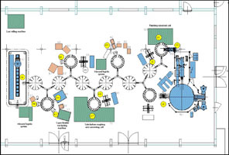 | 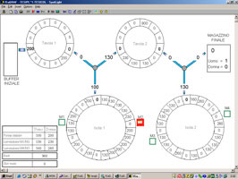
Figure 2: Layout of the Shoe Plant (Left) And Isagraf Simulation Graphical Interface (Right).
At the Beginning of the Design Life Cycle, The Control and Supervision System of the Transport Line Was Specified by Means of Uml (Unified Modelling Language) Diagrams; In Particular Use-Case, Class, Sequence and State Diagrams Were Used to Specify the Systems Modules, Their Relationships and Their Dynamic Behaviour. The System Architecture and Functions Were Designed Using the Function Block Formalism Defined by the Iec 61499 Standard, Which Integrates Object-Oriented Concepts and Discrete Event Models to Suitably Support Control Software Design. The Functional Model Obtained Was Analysed and Optimized by Means of Closed-Loop Discrete Event Simulations Performed in the Simulink/stateflow Environment, Where Both the Controller and the Controlled Process Were Modeled and Simulated Through State Charts, As Was the Behaviour of the Overall System. In This Way, The Correctness and Performance of the Solution Proposed Could Be Evaluated. In Particular, A Bottom Up Methodology Was Defined and Exploited to Study the System According to a Modular Approach. This Enabled Us to Simplify the Overall Analysis Process, To Verify the Correctness of the Automation Functionalities Easily and to Optimize the System Performance From the Very First Phases of the Design Life Cycle. Once the Functional Modules Had Been Verified, The Control and Supervision Algorithms Were Developed Using the Sfc (Sequential Functional Chart) Formalism, Which Is an Advanced Discrete Event Modelling Graphical Language, Directly Derived From Petri Nets, And Included in the Iec 61131 Part 3 Standard, Which Defines Programming Languages for Industrial Plcs (Programmable Logic Controllers). The Sfc Algorithms Were Analysed Through Closed Loop Discrete Simulations in the Isagraf Environment in Order to Verify Their Correctness and to Optimize Their Performance. Isagraf Is a Cacsd (Computer Aided Control System Design) Tool That Allows the Automation Software to Be Structured Using All Five Iec 61131 Languages and Supports Simulation Functionalities for Testing Purposes, As Well As Automatic Code Generation Facilities for Different Industrial Systems. In Order to Perform the Closed Loop Simulations, Simplified Models of the Plant Devices Have Been Represented in Isagraf by Means of Suitable Sfc Modules and Data Structures. Moreover, To Simplify the Analysis of the Simulation Results, A Simple 2d Graphic Animation Was Realized in Isagraf (Figure 2). Simulations Have Been Performed by Considering Typical Operating Conditions, Ie, Typical Production Orders, And the Results Obtained Show That the System Is Deadlock Free and That the Plant Is Well Balanced, Ie It's Resources Are All Used Effectively. After Verification and Optimization of the Automation Functions and Algorithms, The Corresponding Code Was Generated and Implemented On the Target Industrial Devices. We Found That the Simulation-Based Analysis Techniques Reduced the Plant Rump-Up Times and Costs and Improved Overall System Performance. Future Work Will Concern the Exploitation of the Standards, Methods and Tools Proposed for Other Industrial Plants and Their Integration Within an Advanced Cacsd Tool for Manufacturing Systems

Manufacturing
Tomas Bata’s Revolutionary Business Concept Was to Industrialize the Shoemaking Process of That Day. That Type of Thinking has Been the Driving Force Behind the Bata Shoe Organization Success.
The Bata Shoe Organization has Been As Innovator in the Manufacturing of Shoes Over the Years. Bata Personnel Have Made Important Advances in Dvp (Direct Vulcanization Process), Pvc, Athletic Footwear Production and Slush – Molded Footwear Production.

- Raw Material Stock
The Raw Material Which Includes the Chemicals Used for Making Cement Adhesive,Rubber Latex and Sole (Both Inner and Outer),Cloth(Bought From Bombay Dyeing) Used for Making Upper, Material Used for Making Binding,Thread and the Packing Cartons Etc. Are Stocked in the Warehouse. Inventory of All the Above Items Is Properly Maintained with the Help of a ‘material Stock Position’ Chart Made On the Walls of the Warehouse and a Computerized Inventory Database.
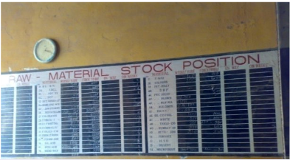

Every Department has Been Allocated a Maximum Stock Limit Beyond Which They Cannot Store the Raw Materials for Themselves. It has to Be Used As Frequently As Possible. Every Fortnight, The Stock and Usage Is Reviewed. The Transmission of Raw Material From Stock Warehouse to Respective Departments Is Recorded and Same Is Done with the Transmission Between Various Departments. All This Data Is Readily Available for Review to All Departments and Can Be Checked Anytime.
Cement and Latex Manufacturing:
The Cement Adhesive and Rubber Latex Are the Main Chemicals Used to Paste Together the Different Part of a Shoe, Are Manufactured in the Plant Itself. Both These Materials Are Produced Keeping in Mind the Exact Requirements and Also the Correct Specification, Which Is the Right Mix of Chemicals to Make It the Best Pasting Element and Get the Desired Quality.
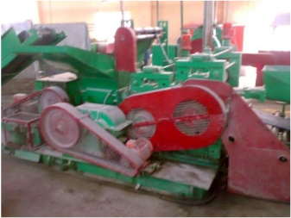

- Sole Pull Manufacturing:
The Inner and Outer Shoe Required in the Shoe Are Also Produced In-House. Huge Rubber Sheets Measuring 3ft.X2ft. Having a Thickness of Approx. 2 Cms. Are First Heated to High Temperature and Then Placed in a Curing Chamber for 8 Minutes Where They Are Again Processed at High Temperature of Around 170oc. At Such a High Temperature the Sheets Expand and Then Sent for Vulcanization Where It Is Processed for 3 Hrs. To Set the Shrinking Limit of Rubber. These Sheets Can Be Cut Only After Two Weeks of Vulcanization. This Is Known As Seating Process.

- Making Binding:
A Binding Is Required On the Outer of the Shoe to Bind the Edges of Cloth Upper. This Binding Material Is Also Made Within the Plant, Using Cloth. It Is Machne Stitched Onto the Cloth Upper.
- Folding, Cutting and Stamping:
The Cloth That Forms the Shoe Upper Is Produced From Bombay Dyeing. It Is First Folded Into Huge Lots and Then Cut Into Pieces of Uniform Sizes According to the Different Size Lots.These Cloth Pieces Are Then Stamped with What May Be Called a Batch Number and the Shoe Size. An Example of a Batch Number May Be “f-3218422”. In This Code, F Represents Plant Code of the Faridabad Factory, 321 Is the Code of the Particular Workstation and Assembly Line, 8 Represents the Year of Manufacturing, 42 The Week and 2 Signifies the Day of the Week in Which Production has Been Done.This Stamping Particularly Helps If There Is a Defect Found Out in the Shoe After Sale. After Stamping Is Done ,The Upper Is Sent for Stitiching.

- Stitching :
The Cloth Received After Stamping Is Set for Stitching and Making It Into a Proper Upper of the Shoe. The Stitching Process Starts with Folding of the Piece and Stitching It in a Particular Fashion to Give the Shape of an Upper. Next, It Is Sent for Stitching the Binding Onto the Edges of the Sgoe. After the Binding On the Edges has Been Done, The Shoe Is Transferred Further Where Lace Holes and Flips Used Under That Are Stitched Onto the Upper. The Last Step in the Stitching Process Is to Put Laces Into the Shoe, Which Is Done by Hands. The Upper of the Shoe Is Now Ready to Sent for Assembling Process.
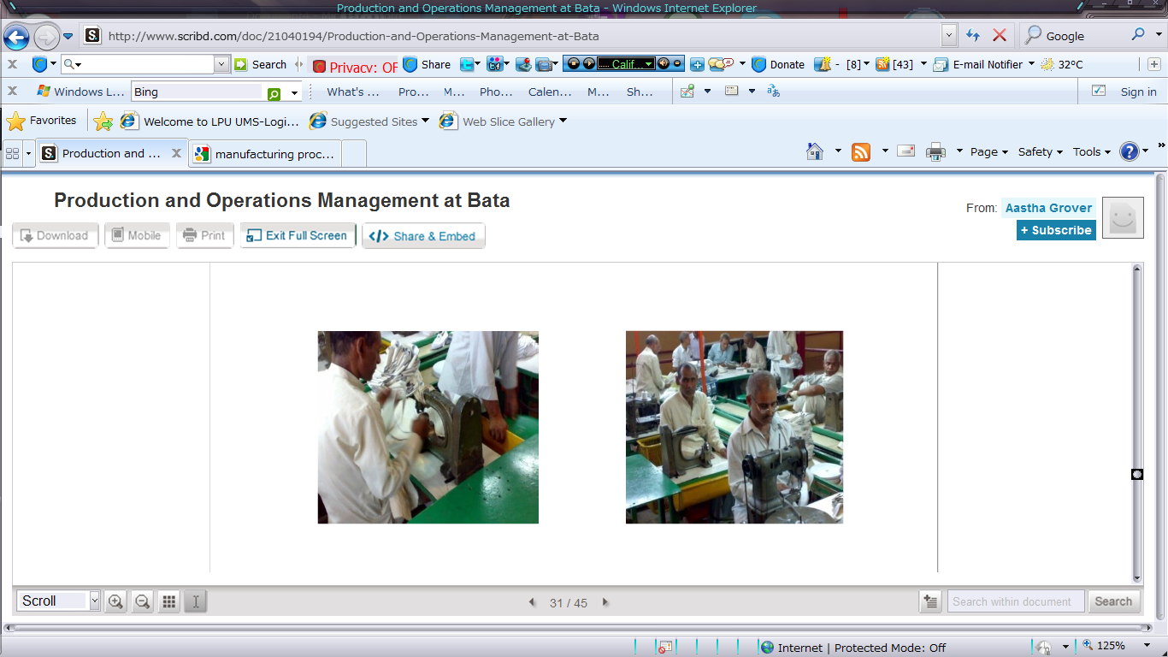
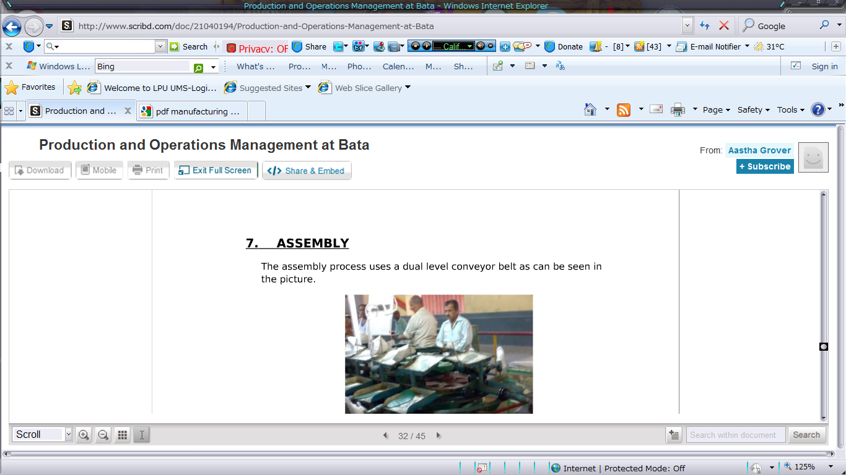
- Assembly:
The Assembly Process Uses a Dual Level Conveyor Belt As Can Be Seen in the Picture.
a Fact Worth Noting Is That the Conveyer Does Not Have a Linear Arrangement of Workstations; Rather It Is an Ellipsoidal Conveyer with Different Workstations Positioned All Around It. At First Glance, It Is Not Easy to Comprehend As to Wherefrom Where the Process Begins. However ,A Closer Look Reveals That Fully Assembled Shoes Are Hand Picked Away From the Conveyer at One Particular Point On the Conveyer. Despite It Unconventional Designe, It Is a Very Well Organized and Systematic Assembly Line Configuration Where None of the Employee Sit Idle at Any Point of Time , Thus Minimizing Idle Time Losses.

There Is a Parallel Conveyer Which Basically Consists of Many Metal Shoe Moulds Onto Which the Entire Shoe Assembly Is Built.
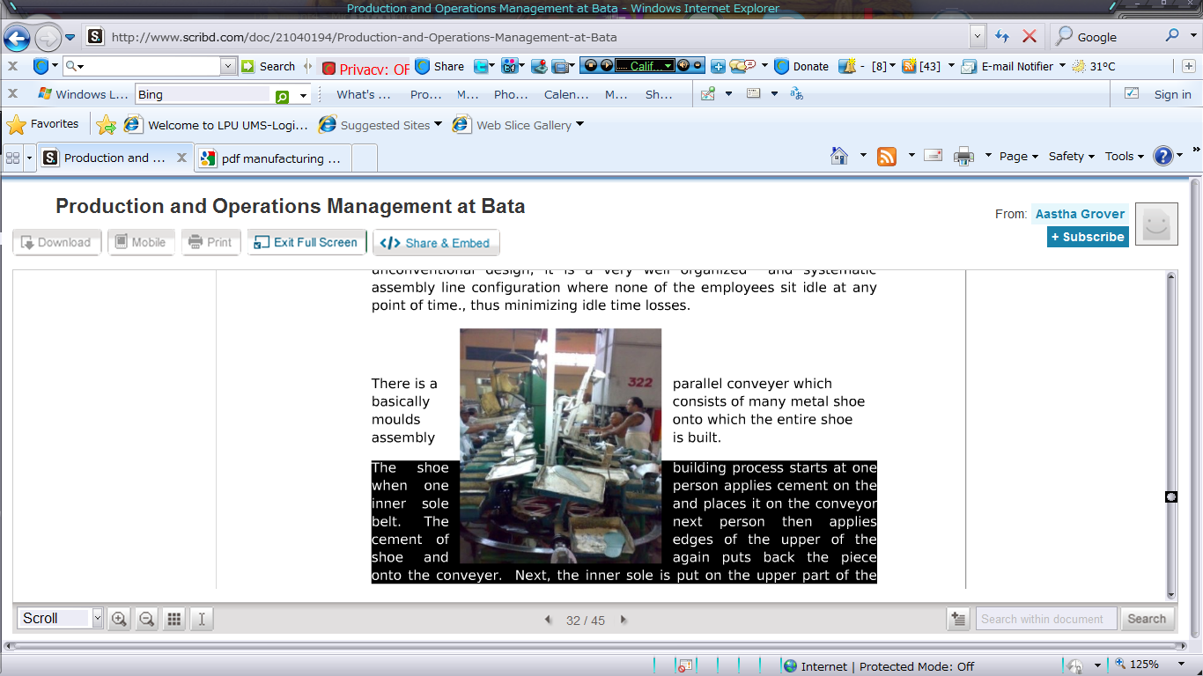
The Shoe Building Process Starts at One When One Person Applies Cement On the Inner Sole and Places It On the Conveyer Belt. The Next Person Then Applies Cement of Edges of the Upper of the Shoe and Again Puts Back the Piece Onto the Conveyer, Next,The Inner Sole Is Put On the Upper Part of The
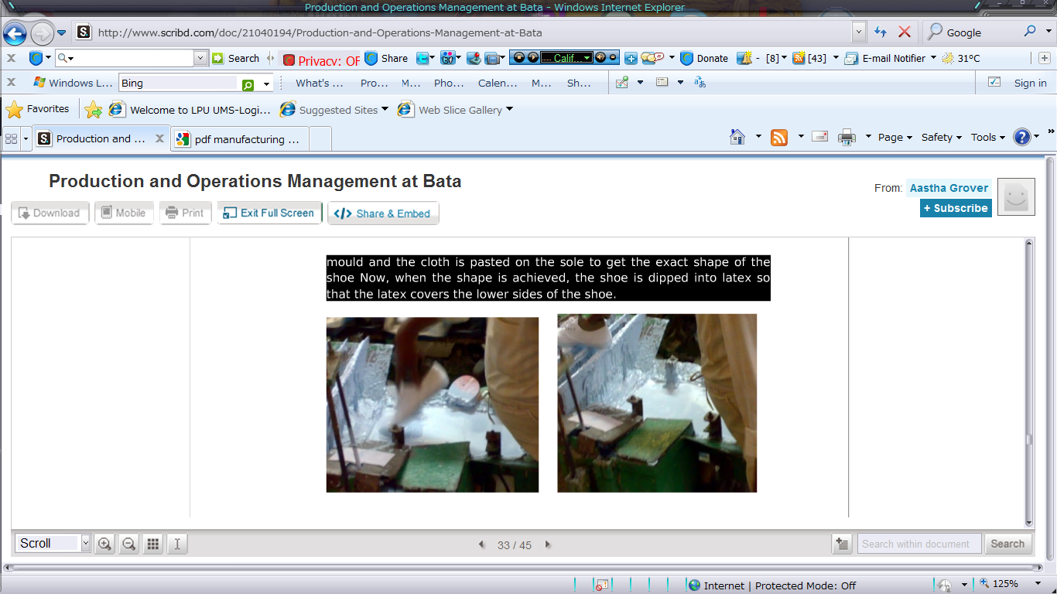
Mould and the Cloth Is Pasted On the Sole to Get the Exact Shape of the Shoe. Now ,When the Shape Is Achieved ,The Shoe Is Dipped Into Latex so That the Latex Covers the Lower Side of the Shoe.
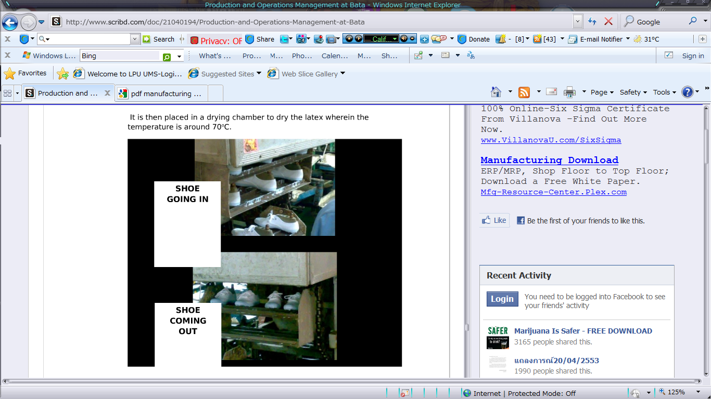
It Is Then Placed in a Drying Chamber to Dry the Latex Where in the Temperature Is Around 70oc.
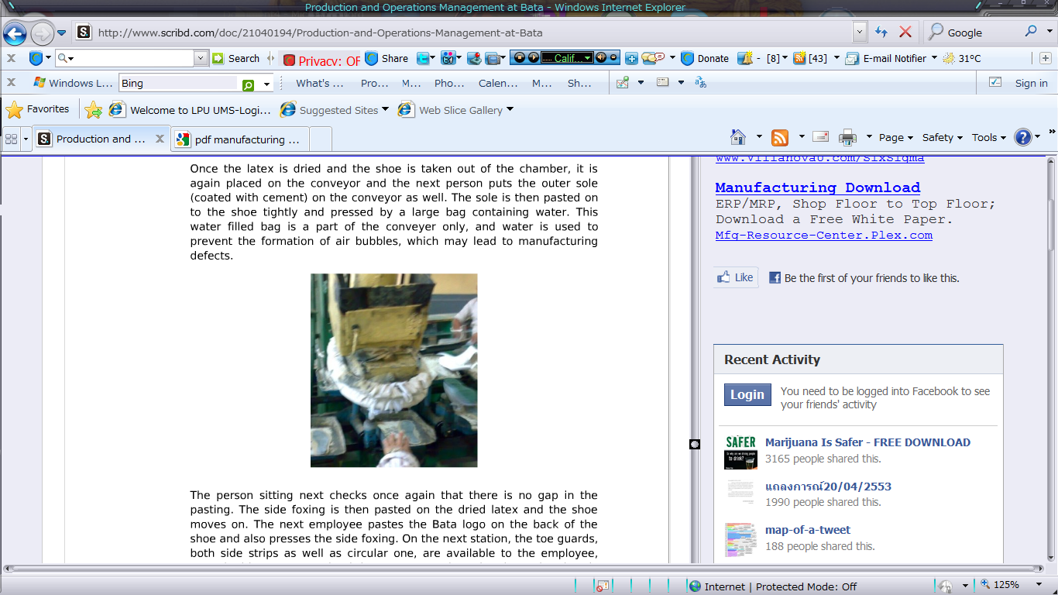
Once Latex Is Dried and the Shoe Is Taken Out of Chamber . It Is Again Placed On the Conveyor and the Next Person Puts the Outer Sole(Coated with Cement) On the Conveyor As Well. The Sole Is Then Pasted On to the Shoe Tightly and Pressed by a Large Bag Containing Water. This Water Filled Bag Is a Part of the Conveyor Only and Water Is Used to Prevent the Formation of Air Bubbles, Which May Leads to Manufacturing Defects.

The Person Sitting Next Checks Once Again That There Is No Gap in the Pasting. The Side Fixing Is Then Pasted On the Dried Latex and the Shoe Moves On. The Next Employee Pastes the Bata Logo On the Back of the Shoe and Also Press the Side Foxing. On the Next Station, The Toe Guards, Both Side Strips As Well As Circular One, Are Available to the Employee.
Coated with Cement . Both of These Are Pasted On the Shoe. The Shoe Is Now Prepared to Be Vulcanized and Hence Is Transferred by the Last Worker On the Conveyor , From the Conveyor to the Conveyor Trolly.
Introduction :

Facility Layout Means Planning:
A.For the Location of All Machine, Utilities, Employee Work Stations Customer. Service Areas, Material Storage Areas, Aisles, Restrooms, Lunchrooms, Internet Walls, Offices and Computer Rooms.

B. For the Flow of Patterns of Materials and People Around, Into, And Within Building.

C .Infrastructure Services Such As the Delivery of Line Communications, Energy and Water and the Removal of Waste Water All Make Up Basic Utilities.

Characteristic of Facility Layout Decision:
A. location of These Various Areas Impacts the Flow Through the System.
B. the Layout Can Affect Productivity and Costs Generated by the System.
C. layout Alternatives Are Limited By

D. the Amount and Type of Space Required For
The Various Areas.

E. the Amount and Type of Space Available.

F. the Operations Strategy.

Objective of Layout Strategy:

Develop an Economic Layout Which Will Meet the Requirements Of:

A. product Design and Volume (Product Strategy)
B. process Equipment and Capacity (Process Strategy)
C. quality of Work Life (Human Resource Strategy)
D. building and Site Constraints (Location Strategy)

Basic Layout Forms:
A. process Layout
B. product Layout
C. combination Layout
D. fixed Position Layout

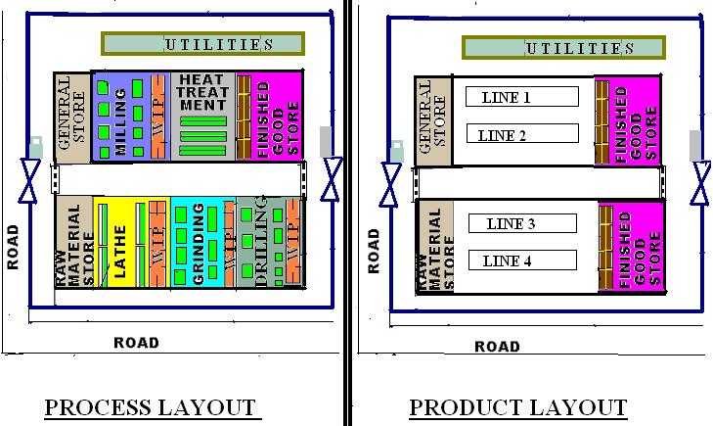

Fixed-Position Layout
in Fixed-Position Layouts, The Item Being Worked On Remains Stationary, And Workers, Materials, And Equipment Are Moved As Needed. Fixed-Position Layouts Are Widely Used for Farming, Firefighting, Road Building, Home Building, Remodeling and Repair, And Drilling for Oil,Buildings, Ships, Aircrafts.

Factors in Determining Layout and Design:

Small Business Owners Need to Consider Many Operational Factors When Building or Renovating a Facility for Maximum Layout Effectiveness. These Criteria Include the Following:

1. ease of Future Expansion or Change Facilities Should Be Designed so That Can Be Easily Expanded or Adjusted to Meet Changing Production Needs. "Although Redesigning a Facility Is a Major, Expensive Undertaking Not to Be Done Lightly, There Is Always the Possibility That a Redesign Will Be Necessary. Therefore, Any Design Should Be Flexible.« Flexible Manufacturing Systems Most Often Are Highly Automated Facilities Having Intermediate-Volume Production of a Variety of Products. Their Goal Is to Minimize Change Over or Setup Times for Producing the Different Products While Still Achieving Close to Assembly Line (Single-Product) Production Rates."
2. flow of Movement the Facility Design Should Reflect a Recognition of the Importance of Smooth Process Flow. In the Case of Factory Facilities, The Plan Will Show the Raw Materials Entering Your Plant at One End and the Finished Product Emerging at the Other. The Flow Need Not Be a Straight Line. Parallel Flows, U-Shaped Patterns, Or Even a Zig-Zag That Ends Up with the Finished Product Back at the Shipping and Receiving Bays Can Be Functional. However, Backtracking Is to Be Avoided in Whatever Pattern Is Chosen. When Parts and Materials Move Against or Across the Overall Flow, Personnel and Paper
Work Become Confused, Parts Become Lost, And the Attainment of Coordination Becomes
Complicated."
3. materials Handling Small Business Owners Should Make Certain That the Facility Layout Makes It Possible to Handle Materials (Products, Equipment, Containers, Etc.) In an Orderly, Efficient²and Preferably Simple Manner.

Facility Location
Contact Person. Address, bata house – 418/02, Gurgaon Mahrauli Road, Sector 17. Gurgaon 122002.
haryana. City, Gurgaon. State, haryana. Phone, 124 4120100
1.Bata Nagar Factory Batanagar, Westbengal

2. Rubber Purchasing Dept. Kottayam, Kerala Rubber Purchase and Processing.

3. Bataganj Factory Bataganj,Patna Bihar Complete Manufacturing

4. Bata Tannery Mokamehghat, Bihar Leather Processing

5 . Faridabad Factory Nit, Faridabad Up Complete Manufacturing

6. Sandak Division Shivaji Marg, Sandak Sandak Footware.

Production Plaaning System Viz Capasity Planning, Operation Management Sheduling Etc.

Product Planning System.
They Select Their Product Designs According to Their Customer Needs. And They Are Continuously Bringing Changes As the Customers’ Demands for New Products. They Are Using the Latest Equipment and Machinery to Meet the Customers Demand and to Provide Them the Product They Need.

Bata Production Division Is Going Extra Miles to Meet Ever Growing Production Requirements of Pu Direct Pouring and Other Footwear to Cater the Needs of Our Worthy Customers. During the Current Season, The Overall Production Is Going 120% Against Estimates and 130% Against Last Year. Similarly in the Area of Pu Direct Pouring, 123% Production has Been Achieved Against the Estimates and 204% Against Last Year.
this Milestone in Production has Been a Result of Restructuring of Maraka and Rubber Factories. A Better Production Planning, Maximum Utilization of Human Resources and Teamwork – All Have Been Put Together Strategically to Achieve Competitive Advantage in “bata” Products Over the Competition in the Area of Quality, Prices and Sales Appeal

Process of Planing Operation System,
Their Process Consists of Three Parts.
- Manufacturing
In Manufacturing Are, All the Raw Materials Are Brought Together and the Raw Material Is Cut Into the Shapes of the Required Products. All the Pieces Are Cut Here for the Specific Products.
- Stitching
The Cut Pieces of Raw Material Are Stitched Here Together to Give the Shape of the Shoe. The Sole Is Also Attached to the Upper Portion of the Shoe and All the Pieces Are Joined Together to Give It the Shape of Shoe.
- Finishing
The Product Is Then Moved to Finishing Department Where the Rough Look of Shoe Is Converted in to a Finished Product. The Shoe Is Polished, Cleaned and All the Unwanted Materials Are Removed From It to Give It a Proper Shape. The Color and Shine of the Shoes Are Finalized Here and the Product Coming Out of This Department Is Ready for Use.

- Retrenchment (Firing)
As We Know That Bata Is a Biggest Firm Around Us and They Hire the Person Who Have the Skills and Ability to Do Work for a Long Time .They Mainly Fire People On the Serious Reach of Agreement, Misconduct, Punctuality and Upon Not Achieving Their Given Targets and Once the Management has Decided to Fire a Person They Give One Month Prior Notice to the Respective Employee and Once the Employee Is Fired Can Never Be Hired Again. Moreover They Do Not Conduct Any Exit Interview. They Do Not Believe in Extending the Outplacement Facility to Their Employees.
Quality System,

An Important Choice
A Choice of More Than 3,000 Items: Footwear, Clothing, Bags and Accessories, For Men, Women, Children and Sports.

A Very Personal Service
Their Professional Specialized Staff Is There to Help You Make the Best Choice

Product Presentation
All the Items Are Clearly Marked with the Price, Size and Description of the Materials Used to Make the Product, Thus Saving You Time and Making Your Choice Easier.

Your Purchase Is Guaranteed
You Have the Guarantee to Replace the Purchased Item If It Is Still Intact and Accompanied by the Till Receipt.
Inventory Management
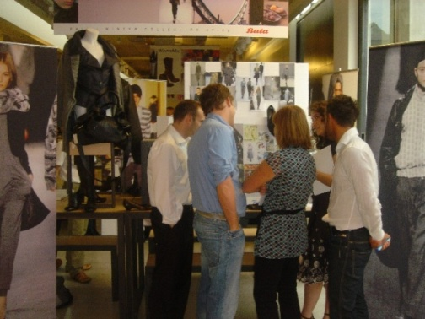
Subject Matter Expert and Course Leader, Jean-Paul Waisman From the European Group with the Support of Vladimir Spelda From Central Europe and Alain Groelly From Switzerland Facilitated the Euro Fast Track Merchandising Module in Italy From June 3rd to 15th. 14 European Participants Took Part in the Training.
the Course Objectives Were As Follows:
~To Learn the “best Merchandising Practices” In the Bata Europe Group
~To Better Understand the Role and Function of the Merchandising Department in the Company
~To Develop and Improve skills in Shoe Line Building
~To Understand, Create and Utilize the Consumer Lifestyles Segmentations
~To Introduce Analytical Tools and Techniques to Perform In-Season and End-Season Analysis in Order to Better Manage Inventory
~To Introduce a Disciplined, Standardized Methodology and Process to the Bata Europe’s Merchandising Function in Order to Align business Performance to Benchmarks
the Participants Worked Through Various Major Business Areas Including:
~Analyzing the Market Place and All the Competition
~Understanding the Need for Market Segmentation to Better Identify Customers' Requirements
~Building a Shoeline with Core and Additional Collections to Better Meet Store Portfolio Requirements
~Planning the Merchandise Allocation to the Stores in Such a Manner That Stores Can Achieve Their Sales Objectives
~Using Various Analytical Techniques to Optimize Sales and Inventory Management, and to Maximize profitability
a Professor From the Ars Sutoria University in Milan Explained in Detail the Various Shoe Construction Types and Material Including Tips to Recognize a "Quality Shoe".
the Group Visited Stores in Venice and Made a Competitive Market Place Analysis Including Business Cases As to How to Improve bata store Performance, Visual Display and Other Areas of the Business.
the Euro Fast Track - Merchandising Module was Very Successful and Participants Were Very Enthusiastic As They participated in Many Practical Exercises Including a Negotiation Workshop. they Also had the Opportunity to Share Their Experiences with Many Colleagues From Other Bso Companies Across Europe.

Supply Chain Management
Bata Is Using It's Raw Materials From His Different Suppliers. Some of the Suppliers Are Local While Some Are From Indonesia. Along with Their Own Production, They Are Also Out Sourcing for Some of Their Products. They Are Keeping a Check On the Quality of the Products From Outsourcing and Using Their Own Brand Name.
The Raw Material Coming From Their Suppliers Are Stored in the Warehouses. These Raw Materials Are Then Moved to the Production Area, Where the Production Is Being Done and the Finished Good Are Moved Towards Warehouse Again for Storage After Proper Quality Inspection. They Are Their Own Distributers and They Have Their Own Stores All Over India. They Have Four Types of Store Concepts.

City Store
The Bata City Store Gives You Unique Shopping Experience As It Showcases the Latest Collections for Footwear of Local and International Brands. The Store Ambience Is Designed to Create a Lifestyle Store That Reflects and Responds to Your Needs and Expectations. The Bata City Stores Are Located in Top Shopping Malls in Big City Centers.

Family Store
Bata Is the World's Leading Family Chain Thanks to the Wide Assortment of Every Fashion Footwear Available in Our Stores. The Products Are Primarily the Bata Brand, With a Carefully Selected Assortment of Articles From Both Local and International Brands.

Superstore
Bata Superstore Offers a Wide Assortment of Fashion, Casual and Athletic for the Entire Family. Located Primarily in Urban and Suburban Shopping Center, These Spacious Stores Offer the Best Value by Providing Good Quality Shoes at Great Prices. Service Is Fast Thanks to a Self-Selection Shopping Environment with Qualified Staff to Serve and Assist.

Factory Store
Factory Stores Are the Largest and the Most Value-Oriented Stores of Our Retail Chain.
they Are Ideally Located in Power Centers, Commercial Parks and Outlet Centers with Easy Parking Facilities. The Product Selection Offers More Than 1,000 Styles of Ladies, Men, Children and Sport Shoes with Related Accessories and Apparel Sold at Attractive Price Points. It Is Based On a Self-Service Concept with Helpful Staff Available for Service at Any Time.

It Appears to Me That Bata Was Very Far in the Direction of Micro Managing. I Do Not Believe He Would Have Been Much Fun to Work For. But It Would Have Been a Rewarding Experience, Not Just From the Point of View of Finances, But Rather Like Having a Very Demanding Teacher. You Do Not Enjoy the Experience at the Time but You Look Back On the Experience with a Certain Fondness. You Realize That You Grew Under the Stress; That You Were Stretched and It Was Good for You.

Bata Tried to Make the Need for Such Micro-Management Less by the Way He Developed His System for Setting Pay and Rewards. He Said: "I Was Seeking a Method Which Would Work Automatically As the Sun Rises and the Sun Sets." He Wanted to Wind the Company Up and Then Let It Run Without His Attention.

In This System, Every Work Unit Was Engaged in 'Buying' And 'Selling' Goods and Services to and From Other Work Units. The Prices Were Established by a Central Accounting Office and Were Not Negotiable. The 'Customer' For the Product or Service Dictated the Quality and Schedule. Naturally the Setting of These Prices Was Subjected to Considerable Discussion and Debate. However, All of the Facts and Figures Used in Setting the Prices Were Available to the Work Unit so They Had a Basis for Their Side of the Debate. The Prices Were Set with Due Regard for Prices of Similar Products Which Might Be Available On the Open Market. Work Units Were Not Constrained to Buy Only From Within the Company.

What Made the Bata System Different From Other Methods of Cost Accounting Was the Agreement That If the Workers Could Devise an Improved Method, Which Reduced Waste, Improved Times of Delivery and Produced a Profit Beyond Expectations, The Workers Could Share in This Profit. In Other Words, Bata Produced a System Which Encouraged Each Work Unit to Become More Entrepreneurial.

Bata Had a Larger Purpose. He Intended for Each Worker to Become Much More Conscious of the Economics of the Factory, To Relate the Results of the Enterprise to His Own Fortunes and to Become a More Responsible Guardian of Wealth. For Bata the System of Internal Transacting Was More Than a Way to Run the Company; It Was a Way to Train People to Become Fiscally Responsible in Their Own Lives.

Biblography
Http://www. Bata.Com
Www.Product Range.Com
Http://www.Bata Manufacturing Process.
Www.Consumercomplaints.In/

More Free Term Papers On Site: Www.Maturski.Org

