Term Paper
Of
Consumer Behaviour

Topic- Consumer Behaviour Towards Sansui T.V In
Jalandhar.

More Free Term Papers On Site: Www.Maturski.Org

Index

Introduction | 4-6
Company Profile | 6-11
Buying Behaviour | 12
Buyer Decision Process | 13-15
Swot Analysis | 16
Objective of the Study | 17
Research Methodology | 18
Review of Literature | 19-22
Data Analysis | 23-33
Recommendation | 33-34
Conclusion | 34
Questionare | 35-36
Reference | 37-38

Introduciton:

Every Business Organization That Comes Into Contact with the Customer Develops a Perception in the Mind of the Customer. Today, In This Competitive World Every Organization Needs to Know the Perception in the Mind of the Customers. In Order to Gain Mind Share or Heart Share of Customers Along with the Market Share Is the Main Lookout for the Organizations. Especially in Consumer Electronics Sector, Where the Products Are More or Less Same, The Only Way to Leave Positive Impact On Customer’s Mind and to Gain Competitive Advantage Is Providing Best Possible Services to the Customers.
Introduction Part of This Report Is Classified Into Two Different Sections.

- Problem Statement the Principle Cause Behind This Project Is to Know That to What Level Customers Are Enjoying and Aware of Sansui TV Offered by the Company and What Further Improvement Can Be Done in Future in This Area so As to Get Brand Awareness.
- Industry Scenario
sansui, A Globally Recognized Brand Name and One of the World Leaders in Consumer Electronics, Was Founded in 1944. Sansui Started Manufacturing Transformers and Subsequently, Expanded Into Manufacturing Hi-Fi Amplifiers and Other Electrical Equipment. Historically, Sansui has Been a Technology Leader in the Electronic Industry, With Such Firsts As: First Audio Transformer; First High Powered Tube-Transistor Amplifier; First in the World with Matrix “surround Sound” In 1970, Stereo Am in 1876 And Digital Sound Processing in 1983, To Mention but a Few.

Sansui Is Now Primarily Engaged in the Design, Manufacture and Marketing of Home Audio / Video Products. Sansui Audio / Video Products Consist of an Extensive Range of Home Theater Systems, Av Receivers, Components Systems. Dvd Players, Mini and Micro Systems, Portables, Discman, Portable Mp3 Players, 5.1 Speaker Systems, And a Range of Television Products That Also Include Lcd / Plasma and Rear Projection Televisions.

Sansui Is Committed to Providing an Integrated Service to Our Customers, Which Consists of Commitment to Excellent Product Quality, Up-To-Date Product Design, Competitive Market Pricing and Constantly Expanding It's Distribution Networks for Easy Access for Our Products. With This Integrated Service As Our Company Goal, We Constantly Strive to Excel Ourselves. Customers World Wide Surely Benefit From Our Services.

About Electronics Industry
History of Electronics in India
The Electronics Industry in India Took Off Around 1965 With an Orientation Towards Space and Defense Technologies. This Was Rigidly Controlled and Initiated by the Government. This Was Followed by Developments in Consumer Electronics Mainly with Transistor Radios, Black & White TV, Calculators and Other Audio Products. Colour Televisions Soon Followed. In 1982-A Significant Year in the History of Television in India – The Government Allowed Thousand of Colour TV Sets to Be Imported Into the Country to Coincide with the Broadcast of Asian Games in New Delhi. 1985 Saw the Advent of Computers and Telephone Exchanges, Which Were Succeeded by Digital Exchanges in 1988. The Period Between 1984 And 1990 Was the Golden Period for Electronics During While the Industry Witnessed Continuous and Rapid Growth.

From 1991 Onwards, There Was First an Economic Crises Triggered by the Gulf War Which Was Followed by Political and Economic Uncertainties Within the Country. Pressure On the Electronics Industry Remained Though Growth and Developments Have Continued with Digitalization in All Sectors and More Recently the Trend Towards Convergence of Technologies.

After the Software Boom in Mid 1990 India’s Focus Shifted to Software. While the Hardware Sector Was Treated with Indifference by Successive Governments. Moreover the Steep Fall in Custom Tariffs Made the Hardware Sector Suddenly Vulnerable to International Competition. In 1997 The Ita Agreement Was Signed at the Wto Where India Committed Itself to Total Elimination of All Customs Duties On It Hardware by 2005. In the Subsequent Years, A Number of Companies Turned Sick and Had to Be Closed Down. At the Same Time Companies Like Moser Baer, Samtel Colour, Celetronix Etc. Have Made a Mark Globally.

In Recent Years the Electronic Industry Is Growing at a Brisk Pace. It Is Currently Worth $ 10 Billion but According to Estimates, Has the Potential to Reach $ 40 Billion by 2010. The Largest Segment Is the Consumer Electronics Segment. While Is Largest Export Segment Is the Consumer Electronics Segment. While Is Largest Export Segment Is of Components.

The Electronic Industry in India Constitutes Just 0.7% Of the Global Electronic Industry. Hence It Is Miniscule by International Comparison. However the Demand in the Indian Market Is Growing Rapidly and Investments Are Flowing in to Augment Manufacturing Capacity. India However Remains a Major Importer of Electronic Materials, Components and Finished Equipment Amounting to Over Us$ 11.6 Bn at Present.

India Is Also an Exporter of a Vast Range of Electronic Components and Products for the Following Segments:

- Display Technologies
- Entertainment Electronics
- Optical Storage Devices
- Passive Components
- Electromechanical Components
- Telecom Equipment
- Transmission & Signaling Equipment

India Is Also an Exporter of a Vast Range of Electronic Components and Products for the Following Segments:

- Display Technologies
- Entertainment Electronics
- Optical Storage Devices
- Passive Components
- Electromechanical Components
- Telecom Equipment
- Transmission & Signaling Equipment
- Semiconductor Designing
- Electronic Manufacturing Services (Ems0)

Company Profile
About Sansui
Brief Profile

Sansui Electric Co. Ltd. Is a Japanese Manufacturer of Audio and Video Equipment. Headquartered in Tokyo, Japan, It Is Part of Grande Holdings, A Chinese Hong Kong – Based Conglomerate, Who Also Owns Japanese Brands Akai and Nakamichi.
Founded in Tokyo in 1947, Sansui Initially Manufactured Electronic Parts, But by the 1960’s Had Developed a Reputation for Making Serious Audio Components. They Were Sold in Foreign Markets Through That and the Next Decade. Sansui’s Amplifiers and Tuners From the 1960s and 1970s Remain in Demand by Audio Enthusiasts.

In the UK Around 1982, The Sansui Au-D101 Amplifier and It's More Powerful Sibling the Au-D33, Were Highly Acclaimed by Audiophiles and Were so Well Matched to a Pair of Kef Coda III Speakers That They Could Be Bought As a Set From Some Outlets. These Amplifiers Used a Complex Feed – Forward Servo System Which Resulted in Very Low 2nd Order Harmonic Distortion. Despite This Success, Sansui Completely Failed to Follow Up with Further Mass Market Audiophile Components.

As the Mid 1980’s Arrived, Sales Were Lost to Competitors (Sony, Pioneer, And Matsushita’s Technics). Sansui Began to Lose Visibility in the United States Around Company Began to Manufacturing High – End Components in Japan. The Company Began to Manufacture High-End Television Sets and Other Video Equipment, But Ceased Exportation. In the Late 1990’s, The Company’s Brand Was Used On Video Equipment Manufactured by Other Companies. The Current Manufacturer of the Rebranded Sets Is Orion Electric, Based in Osaka and Fukui, Japan. It's U.S. Subsidiary Markets Products Under the Sansui Brand, Among Others. Sansui Is Thus a Mere Umbrella Brand at Present. This Radical Change in Sansui’s Corporate Identity has Resulted in a Notable Change in It's Product Quality As Consumers Now Tend to Consider Sansui a Mass-Market Brand Rather Than a Maker of High-End Electronics.

Recent Awards
may, 2007 World Most Ethical Companies (Ethisphere Magazine)
january, 2007 100 Best Corporate Citizens.
january, 2007 Forbes, 2006 Honour Roll.
march, 2007america’s Most Share Holder Friendly Companies
march, 2007 Black Pearl Award for Corporate Excellence in Good Safety and Quality.
april 2008 Sponsors Tele Award 2007

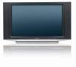 | Sansui 42 Inches Lcd TV - Pdp 4244  brand :sansui  now: Rs.64990  rs.21663 for 3 Months | 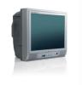 | Sansui 14 Inches TV - Cine Sargam 14  brand :sansui  now: Rs.3990  rs.1330 for 3 Months

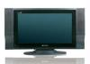 | Sansui 26 Inches Lcd TV - Kyuuten Lcd 264h  brand :sansui  now: Rs.33990  rs.11330 for 3 Months | 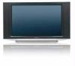 | Sansui 40 Inches Lcd TV - Kyuuten Lcd 401h  brand :sansui  now: Rs.74990  rs.24997 for 3 Months
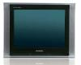 | Sansui 15 Inches TV - Hr 154 Eye  brand :sansui  now: Rs.5750  rs.1917 for 3 Months | 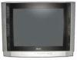 | Sansui 21 Inches TV - Hr 22 Eye  brand :sansui  now: Rs.10790  rs.3597 for 3 Months
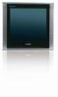 | Sansui 21 Inches TV - Hr 24 Eye  brand :sansui  now: Rs.11290  rs.3763 for 3 Months | 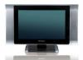 | Sansui 20 Inches Lcd TV - Kyuuten Lcd 205  brand :sansui  now: Rs.19990  rs.6663 for 3 Months

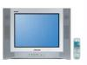 | Sansui 21 Inches TV - Hardrock 2kwt  brand :sansui  now: Rs.8190  rs.2730 for 3 Months |  | Sansui 20 Inches Lcd TV - Kyuuten Lcd 204  brand :sansui  now: Rs.19990  rs.6663 for 3 Months
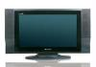 | Sansui 19 Inches Lcd TV - Kyuuten Lcd 194  brand :sansui  now: Rs.18990  rs.6330 for 3 Months | 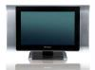 | Sansui 19 Inches Lcd TV - Kyuuten Lcd 195  brand :sansui  now: Rs.18990  rs.6330 for 3 Months

Consumer Behavior
The Aim of Marketing Is to Meet and Satisfy Target Customers’ Needs and Wants. The Field of Consumer Behaviour Studies How Individuals, Groups, And Organizations Select, Buy, Use, And Dispose of Goods, Services, Ideas, Or Experiences to Satisfy Their Needs and Desires. The Consumer Buyer Behaviour Is the Buying Behaviour of Final Consumer–individuals and Households Who Buys Goods and Services for Personal Consumption.
Understanding Consumer Behaviour and “knowing Customers” Are Never Simple. Customers May State Their Needs and Wants but Act Otherwise. They May Not Be in Touch with Their Deeper Motivations. They May Respond to Influences That Change Their Mind at the Last Minute. Nevertheless, Marketers Must Study Their Target Customers’ Wants, Perceptions, Preferences, And Shopping and Buying Behavior:
Studying Consumers Provides Clues for Developing New Products, Product Features, Prices, Channels, Messages, And Other Marketing-Mix Elements.

A Model of Consumer Behavior
At One Time, Marketers Could Understand Consumers Through the Daily Experience of Selling to Them. But the Growth of Sansui Companies and Markets has Removed Many Marketing Managers From Direct Contact with Customers. Increasingly, Managers Have Had to Rely On the 7 O’s Framework for Consumer Research to Answer the Following Key Questions About Any Market:
Who Constitutes the Market? Occupants
What Does the Market Buy? Objects
Why Does the Market Buy? Objectives
Who Participates in the Buying? Organizations
How Does the Market Buy? Operations
When Does the Market Buy? Occasions
Where Does the Market Buy? Outlets
The Starting Point for Understanding Buyer Behavior Is Stimulus-Response Model Shown Below. Marketing and Environmental Stimuli Enter the Buyer’s Consciousness. The Buyer’s Characteristics and Decision Process Lead to Certain Purchase Decisions. The Marketer’s Task Is to Understand What Happens in the Buyer’s Consciousness Between the Arrival of Outside Stimuli and the Buyer’s Purchase Decisions. They Must Answer Two Questions:
- How Do the Buyer’s Characteristics-Cultural, Social, Personal, And
Psychological-Influence Buying Behavior?
- How Does the Buyer Make Purchasing Decisions?

Marketing  Stimuli | Other Stimuli | Buyer’s Characteristics | Buyer’s Decision Process | Buyer’s Decision
Product  Price  Place  Promotion | Economic  Technological  Political  Cultural | Cultural  Social  Personal  Psychological | Problem Recognition  Information Search  Evaluation  Decision  Post Purchase Behaviour | Product Choice  Brand Choice  Dealer Choice  Purchase Timing  Purchase Amount

The Buyer Decision Process

The Buyer Decision Process Consist of Five Stages-: Need Recognition, Information Search, Evaluation of Alternatives, Purchase Decision, And Post Purchase Behaviour. Clearly the Buying Process Starts Long Before Actual Purchase and Continues Long After. Marketer Need to Focus On the Entire Buying Process Rather Than On Just the Purchase Decision.

- Need Recognition- The First Stage of the Buyer Decision Process in Which the Consumer Recognizes a Problem or Need of Sansui TV.
- Information Search- The Stage of the Buyer Decision Process in Which the Consumer Is Aroused to Search for More Information; The Consumer May Simply Have Heightened Attention or May Go Into Active Information Search to the Colour TV.
- Evaluation of Alternatives - The Stage of the Buyer Decision Process in Which the Consumer Uses Information to Evaluate Alternative Brands in the Choice Set.
- Purchase Decision- The Stage of the Buyer Decision Process in Which the Consumer Actually Buys the Product.
- Post Purchase Behaviour-The Stage of the Buyer Decision Process in Which the Consumer Take Further Action After Purchase Based Their Satisfaction or Dissatisfaction.

Marketing Mix

Marketing Mix Can Be Defined As the Set of Controllable Tactical Marketing Tools – Product, Price, Place, Promotion-That the Firm May Blend to Produce the Response It Wants in the Target Market.

Product-Product Means the Goods and Services Combination the Company Offers to the Target Market. In Case of Sansui Television It Includes Variety, Quality, Design Feature, Brand Name, Packaging, Services That Are Offered Along with the Television.
Price- It Is the Amount of Money the Customers Have to Pay to Obtain the Product of Sansui TV. It Includes List Price, Discount, Allowances, Payment Period, And Credit Terms.
Place- It Includes Sansui TV Activities That Make the Product Available to Target Consumers. Channels, Coverage, Assortments, Locations, Inventory, Transportation, Logistics Becomes the Part of Place
Promotion- Promotion Means Activities That Communicate the Merits of the Sansui TV and Persuade Target Consumer to Buy It. Various Promotional Activities Are Advertising, Personal Selling, Sales Promotion, Public Relations.

Factors Affecting Consumer Behavior

Consumer Purchases Are Influenced Strongly by Cultural, Social, Personal, And Psychological Characteristics. For Most Marketer Cannot Control Such Factors, But They Must Take Them Into Account.

- Cultural Factors
Culture Factors Exert the Broadest and Deepest Influence On the Consumer Behavior the Marketer Needs to Understand the Role Played by the Buyer’s Culture, Subculture, And Social Class.

(I) Culture- The Set of Basic Values, Perception, Wants and Behavior of the Sansui TV Learned by the Member of the Society From Family and Other Important Institutions.
(II) Subculture- A Group of People with Shared Values System Based On Common Life Experiences and Situations of the Colour Television.
(III) Social Class- Relatively Permanent and Division in a Society House Members Share a Similar Values, Interests, And Behavior of the Which Brand of Colour TV.

(B) Social Factors
A Consumer’s Behavior Is Influenced by Social Factors, Such As the Consumer’ Small Group, Family and Social Roles and Status
(I) Group- Two or More People Who Interact to Accomplish Individual
L or Mutual Goals.
(II) Family- The Family Members (Husband, Wife, And Children) Can
Strongly Influence Buyer Behavior
(III) Role and Status- Role Consist of the Activities People Are Expected
To Perform According to the Persons Around Them Status Reflect the General Esteem Given to It by the Society. People Choose the Products That Show Their Status in the Society.

(C) Personal Factor
A Buyer Decision of Sansui TV Also Are Influenced by Personal Characteristics Such As the Buyer’s Age Life Style, And Life Cycle Stage, Occupation ,Economic Situation , Lifestyle , And Personality and Self Concept Depend Upon the Personal Factor.
(I) Age and Life Cycle Stage- People Change the Goods and Services They Buy Over Their Lifetime. Tastes of the People Undergo Change with Their Age.
Family Life Cycle- The Stages Through Which Families Might Pass As They Mature Over Time.
- Occupation – A Person’s Occupation Also Affect the Goods and Services They Bought.
- Life Style- A Person’s Pattern of Living As Expressed in His/her Activities, Interest, And Opinion.
- Personality-A Person’s Distinguishing Psychological Characterstics That Lead to Relatively Consistent and Lasting Responses to His or Her Own Environment.

- Psychological Factors
A Person’s Buying Sansui TV Are Influenced by Four Major Psychological Factors: Motivation, Perception, Learning, And Beliefs and Attitudes.
(I) Motivation- A Need That Is Sufficiently Pressing to Direct the Person to Seek Satisfaction of the Need.
(II) Perception- The Process by Which People Select, Organize, And Interpret Information to Form a Meaningful Picture of the World.
(III) Learning- Changes in the Individual’s Behavior Arising From Experience.
(IV) Beliefs and Attitude- Belief Is a Descriptive Thought a Person Hold About Something Attitude Is a Person’s Consistently Favorable or Unfavorable Evaluation, Feelings, And Tendencies Towards an Object or Idea.

Swot Analysis of Sansui TV
Strengths | Weaknesses
1. Specialist in Sound Feature | 1. Low Market Penetration
2. Highly Focus On Response Time | 2. No Exclusive Show Rooms
3. Highly Focus On Delivery Time | 3. Advertising Strategies
4. Good Internal Environment | 4. Positioned Itself As a Mass Marketer
5. Cheap Price | 5. Less Focus On Unconventional Channel
6. Global Acceptance | 6. Product Demo Not Available
 | 7. Not Providing Good Service

Opportunity | Threats
1. Moving Into New Attractive Market Segments. | 1. A New Competitor in Your Own Home Market.
2. Tapping of Rural Market | 2. Competitor has a New, Innovative Substitute Product or Service.
3. Focussed On Unconventional Channels | 3. Increased Trade Barriers.
4. Mergers, Joint Venture of Strategic Alliances | 4. Increased Trade Barriers

Objectives of the Study

The Buying Behavior of the Consumer with Regard to Sansui TV Is Influenced by Number of External and Internal Factors and This Study Attempts to Know About the Consumer Buying Behavior and at the Same Time What Factors Do the Consumers Have in Their Mind Before They Make Up Their Mind to Purchase a Sansui TV so the Main Aim of My Study Was:-

- To Determine the Most Preferred Brand.
- To Determine the Most Preferred Features That the Consumers Look for While the Selection of Sansui Brand.
- To Determine the Level of Satisfaction with Regard to Services Provided Retailers and Brand Already Owned by the Consumer.

Research Methodology

- Formulating the Objectives of the Study;
- Identity and Defining Problem
- Selecting a Research Method; Surveys; Interview and Other Methods.
- Collecting the Secondary Data Through Company Web Sites, Journals and Annual Report.
- Evaluating the Data and Interpreting the Results.

Data Collection:

Primary Data
Primary Data of Research Are Collected From Direct Resources (Customer of Colour Television) Through Questionnaire.

Secondary Data
Secondary Data Which Are Used for Research to Know the History Scop of Sansui Industry Are Collected From Already Available Resources Like Net and Other Sources.

Sampling Technique
Convenience Sampling Is Used for Research Project. I Have Given Equal Weight Ages to My All Respondent and Chose Them Randomly Without Any Biased Like Gender, Age, Income Culture.

Sample Size
100 Respondents has Selected As Sample Size for Research.

Data Representation Technique and Tools
Columns Chart & Pie Chart has Used for Representation.

Review of Literature
G.I. Heald (1970) “the Relationship of Intentions to Buy Consumer Durabbles with the Levels of Purchace”this Paper States the Traditional Short-Term Econometric Forecasting Models for Durables and Generally Represents Expenditure As a Function Disposable Income Relative Price an Index of Purchase Control and As an Estimation of Total Stock of Durables.

J. Pickering (1978) “the Durable Purchasing Behaviour of the Individual Household” He Points Out That Cross –sectional Investigations Perform Reasonably Well in Explaining Individual Household Behavior. Both in Terms of Level of Outlay On Consumers Durables and in Identifying Purchasers of Particular Commodities.

Saikat Banerjee (2008)“dimensions of Indian Culture, Core Cultural, Values and Marketing Implications” He Explained That the Behavior of a Consumer Largely Depends On Interplay Between Inner Self and Outer Stimuli. Consumption Decision Made in the Market Cannot Be Viewed As an Independent Event. It Is Closely Related with Values and Social Relationship and Cultural Allegiance.

Mandar Naresh Dhumal and Avishkar Tayade (2008) “rural Marketing- Understanding the Consumer Behaviour and Decision Process” Explained in This Paper Rural Population Account for 70% Of the Indian Population and It Is Increasing at the High Rate in Comparision to Urban Population. The Buyer of Rural and Urban Area Different in Their Characteristics While Buying Any Product. The Reason Behind It's Differentiation Are Many Like;- Age and Life Style. Occupation. Economic Situation Life Style. Personality and Self Concept. Psychological Factors Like Perception Cognition and Motivation.
Buying Decision of the Consumer of Different Age Occupation Differ From Rural Area to Urban Area the Rural Area Is Move Bounded by the Tradition , Custom, And Value Which Bring a Gigantic Change in the Life Style and Personality of the Customers of the Rural Area in Comprasion to Urban Area. Where People Are More Attached Towards the Welter Cultural Now Per Capita Income of the Consumers in the Rural Area Restrict Them for Low Consumption Pattern As Compared to Urban Population. Where the Consumers Are Brand Conscious and Are Ready to Pay High.

Gurav Kunal(2008) “impact of Relationship Marketing Strategy in Customer Loyality” Explained in This Paper That Their Need to Be Developed Customer Loyality and Pay the Much More Concentration On Marketing Strategy and Relationship Between Promotional Schemes, Customer Trust, And Customer Face to Face Communication.

Chattopadhyay Tanmay and Shivani Shraddha (2009)” Do Multiple Time Consumers Also Observe Imperfectly. The Case of Automobile Consumers in India” He Explained the Customers Holistic Perceptions of the Extra Value Due to Brand Name. The Researcher Also Explained That Any Organization That Makes a New Product for Society Always Takes Care of Products, Price, Brand Name, Quality and Perceptions of the Consumers. Generally Consumer Perceptions Is That Higher Price Is Associated with Better Quality of the Product Which May Not Be True.

Prof. Shilpa. S.Kokatnur (2009) “consumer Perception Brands. An Empirical Examinations”. In This Study Researcher Observed That Consumers On Quality , Money, Packaging, Taste, Price, And Brand Image of Products. Therefore There Is a Need of Making Brand Image Image in Front of Customer.
Sumangale and Uppar (2009 ) Purchasing Practices of Consumer Durables Among ‟ Farm Familities of Gadaj District “he Pointed Out That Selected 5% Of Villages of Gadaj District for a Primary Survey. They Used Purposive Sampling for the Survey to Require Practices of Consumer Durables. The Household Purchased Food Items On a Weekly Basis From Nearby Town.”daily Wear of Women and Men and Kids Were Purchased Once in Six Months. But Used Credit and Instalment System for Purchasing Motorcycle and Television Friends Were Their Sources of Information for Purchased.
J.Lilly. (2010) “customer Perception and Preference Towards Branded Products. With Special Reference to Television Sets”. He Points Out That to Move Consumers From Trial to Preference, Brands Need to Deliver On Their Value Proposition, As Well As Dislodge Someone Else From the Customer’s Existing Preference Sets. Preference Is a Scale, And Brand Moves Up, Down and Even Off That Scale with and Without a Vigilant Brand Management Strategy. Pricing, Promotional Deals and Products Availability. Aristotle Professed, Attaining and Sustaining Preference Is an Important Step On the Road to Gain Brand Loyalty. This Will Help to Generate More Revenue, Gain Greater Market Share and Beat Off the Competition.

Makkar Urvashi and Dhyani Vijendra (2010) “consumer Perception Towards Different Media Options.-An Empirical Study of Rural and Urban Perspective” Explained in This Paper Helps the Marketers to Focus Attention On the Diverse Media Vehicles in General and Media Specifically. Which Are the Key Buying Guides for the Customers in Urban Markets. Provide Insight in the Formulation of Further Media Strategy by the Marketers Enabling Them to Focus On Right Media Choice and Media Mix Once Thing That Is Sure Is That the Media Is Having a Dramatic Impact On the Consumption Patterns of the Consumers Irrespective of Their Affiliation to Certain Geographical Location Rural and Urban and Their Gender. Even in This New Business Environment Where Electronic Transactions Are Becoming the Norms. He Use of Other Media Option to Document Business Transaction Is Equally Important. Specifically for the Rural Customers Indeed As Per the Current Researches.

Rani .S. Sakthivel (2010) “consumer Behaviour in Rural Market A-B-C-D Paradigm and It's Application” Explained in This Paper the Most Important Difference Between the Rural and Urban Is in Degree of Sophistication of the Consumer. Urban Consumers Are Generally Familiar with Such Products Home Their Address and Value Related to Purchase and Consumption Will Be Different. The Conversion of Rural Consumers to Purchase Sophistication Products Is Great Challenge for the Markets. But This Kind Ensure a Good Demand for Sophistication Product in the Future Here in the Marketer May Have to Work Harder to Sell Their Goods in Rural Areas Because of Diversity of Value and Attitude Present in Three Region. Use Term Such As “new and Improved” Since These May Be Effective in Rural Areas. Examine the Obstacles in the Path of Consumers Access to Information and Illiteracy and Diverse Methods to Overcome These Kind of Obstacles Note the Cultural Similarities in Consumer Behaviour Which Might Allow Standardization of Marketing Strategies Across Countries However It Must Be Noted That It Is Possible to Capitalize On the Similarties Among the Rural Markets. Several Researcher Have Suggested to Possibilities of Clustering Area Which Allow the Standardization of Marketing Strategies Across These Region.

.

Data Analysis
- Occupation
Service | 42%
Business Man | 58%

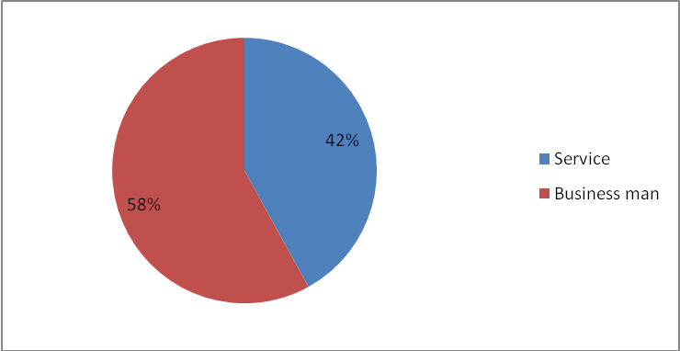

Data Interpatation:

In Total Respondent We Analyse That Most of the People Are Businessman 58% And 42%people Are Service Man in Jalandhar or Out of the City.

- Do You Have TV at Your Home?
Yes | 80%
No | 20%

Data Interpatation:

In Total Respond We Analyse That Show the Chart 80% People Have a Colour Television and 20% People Have Not TV.

- Which Brand Do You Have?

Sony | 30%
Sansui | 15%
Samsung | 15%
Onida | 10%
Lg | 35%
Videocon | 5%

Data Interpatation:

Although There Is Lot Many Competitors in Television Section Among All This Lg Is the Leading Market Share .Show the Data Many Colour TV Company Are Available in the Market. Then Sony TV Consumer Are 30%, Sansui TV Consumer Are 15%,Samsung TV Consumer Are15%,Onida TV Consumer Are 10%, Lg TV Consumer Are 35%,And Videocon Consumer Are 10%.Lg Customer Are More Than Compare to Sansui TV.

- From Where You Come to Know About This Brand?
Advertisement | 55%
Dealer Suggestion | 15%
Friends & Relatives | 24%
Newspaper | 6%

Data Interpatation:
In Total Respondent We Analyses That Most of the Customers Are Attract On Advertisement of the Product and the Decide of the Buy a Product. Show the Data 55% People Are Known to the Product of Advertisement, 15% People Are Depend On Dealer Suggestion, 24% People Are Depend On Friends and Relative Suggestion, And 6% People Are News Advertisement.

- What Factors Influences You to Purchase the Product?
Price | 35%
Feature
  15%
Quality | 30%
After Sales Service | 10%
Providingmaximum Guarantee Period | 10%
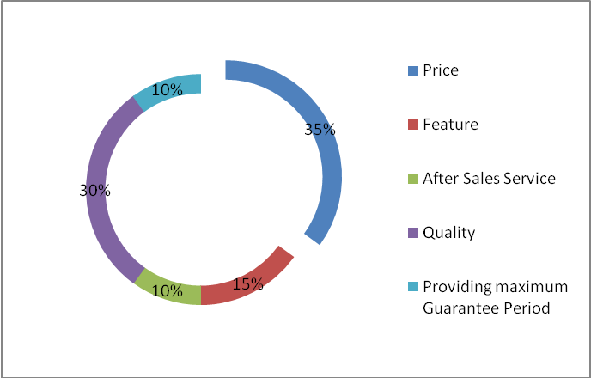
Data Interpatation:
In Total Respondent We Analyses That Most of the Consumer See the Price, Feature ,Sales Service, Quality and Providing Max. Guarantee Period See to the Consumer and Decide to the Product Buy or Not Buy. Show the Data Many Consumers Want of Quality.

- Who Influences You More to Purchase the Particular Brand?
Wife | 20%
Friends & Relative | 25%
Son / Daughter | 35%
No Body | 20%
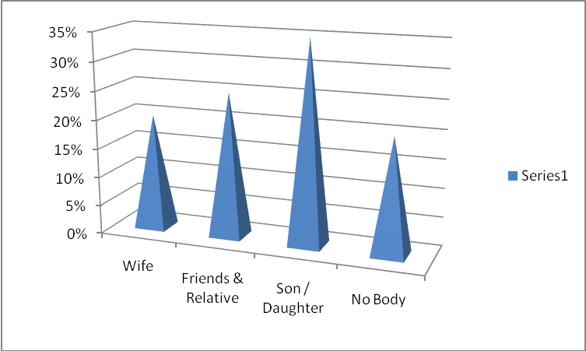

Data Interpatation:
In Total Respondent We Analyses That Most of the Consumer Influence More Purchase to Particular Product Take the Suggestion of Wife, Friends and Relative, Son/daughter, And No Body. Show the Data Many Consumer Are Influence of Son/daughter.

- If Are You Aware of Sansui?
Yes | 73%
No | 27%

Data Interpatation:
In Total Respondent We Analyses That Most of the Consumers (73%) Are Aware of the Sansui Product and 23% Consumers Are Not Aware of the Sansui Product.

- Why Don’t You Use Sansui Tv?
High Price | 24%
Poor Quality | 46%
Less Awareness | 10%
Any Other | 20%

Data Interpatation:

In Total Respondent We Analyses That Most of the Consumer Don’t Use Sansui TV Many Reasons High Price, Poor Quality, Less Awareness, And Any Other. Many Consumer Are Not Use of the Sansui Provide of Poor Quality.

- Do You Setup Your Mind to Purchase Any TV in Future?
Yes | 85%
No | 15%
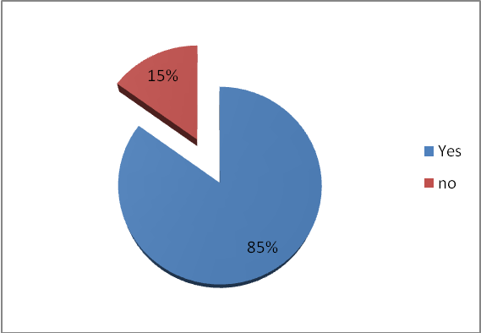
Data Interpatation
In Total Respondent We Analyses That Most of the Customer Are Set Up of the Mind Purchase of the Colour Television in Last Six Month.

- If Yes, Then Which Brand?
Sony | 28%
Sansui | 16%
Samsung | 18%
Lg | 32%
Other | 6%

Interpretation-
In Total Respondent We Analyses That Most of the Consumer Are Buy of the Colour Television Want to Consumer Lg and Sony Compare to Other Company.

Recommendation
I Recommended That Sansui Should Also Concentrate More in Technological Advancements Which More of the Consumers Are Expecting Now in the Present World. In the Same Way Sansui Can Also Concentrate and Try Launching Led’s Which Will Be the Future After Lcd’s. The After Sales Service Must Be Taken Care of Every Point of Time Because Worst Backup Service May Spread Negative Image Among the Potential Consumers Therefore Affecting Sales Drastically Care Should Be Taken for That Sansui Can Also Improve It's Range of Products From the Current to Advanced, It Can Launch Various Home Appliances Inductions Which More Consumers Are Referring Now Instead to Be More Cost Effective, In the Same Way Can Also Introduce More Models.
Similarly Sansui has Good Base Here in the Region Jalandhar Where the Study Was Conducted but Unfortunately It Fails to Utilize It Fully Up to the Level, Hence It Must Be Taken in Mind and Measures Should Be Framed for Utilizing the Capacity. It Can Be Effectively Done Through Various Sales Promotions Activities and Building a Good Rapport with the Dealers and Distributors in the Locality Because They Only Act As the Mains Source for Supplying the Products.
The Pull and Push Strategies Must Be Often Discussed with Them for Effectively Marketing the Products. Various Offers and Incentives Can Be Offered to Them Apart From Doing so to Consumers in Order to Improve the Sales Effectively.
Most of the Dealers Here in This Region Are Dealing with Various Brands Simultaneously so Care Must Be Taken That Sansui Should Be Their First Preference Selling It to the Consumers. Hence It Should Be Considered and Various Offers and Dealings Should Be Made with Them.

Conclusion:

Sansui a Part From Concentrating in the Quality and Improvement of It's Products Can Also Try to Improve It's Reach to the Consumers. Consumers Are Always in Search for Good Quality with Affordable Price so Sansui Can Go with Such an Idea of Capturing the Market by Attracting of Consumer .

Questionnair
- Name
- Age i) 25-30 Years [ ] ii) 30- 35 Years [ ]
III) 35-40 Years [ ] iv) 40-45 Years [ ]
- Occupation i) Business [ ]
II) Service [ ]
- E-Mail Id
- Phone No
- Do You Have TV at Your Home?
I) Yes [ ] ii) No [ ]
- Which Brand Do You Have?
-----------------------------------------
- What Made You Choose the Brand?
------------------------------------------
- From Where You Come to Know About This Brand?
I) Advertisement [ ] ii) Dealer Suggestion [ ]
III) Friends & Relatives [ ] iv) Newspaper [ ]
- What Factors Influences You to Purchase the Product?
I) Price [ ] ii) Feature [ ]
III) After Sales Service [ ] iv) Quality [ ]
v) Providing Maximum Guarantee Period [ ]

- Who Influences You More to Purchase the Particular Brand?
I) Wife [ ] ii) Friends & Relative [ ]
III) Son / Daughter [ ] iv) No Body [ ]
- If Are You Aware of Sansui?
I) Yes [ ] ii) No [ ]
- Which Features Have Sansui TV Do You Find Interesting?
- Why Don’t You Use Sansui Tv?
I) High Price [ ] ii) Poor Quality [ ]
III) Less Awareness [ ] iv) Any Other [ ]
- Do You Setup Your Mind to Purchase Any TV in Future?
I) Yes [ ] ii) No [ ]
- If Yes, Then Which Brand?
I) Sony [ ] ii) Samsung [ ]
III) Lg [ ] iv) Sansui [ ]
V) Other [ ]

References
Books:
- Schiffman and Kanuk, Consumer Behavior.
- Website
- Http://www.Sansui.Com
- Http://info.Shine.Com/company/mirc-Electronics-Ltd/910.Aspx
- Http://www.Euromonitor.Com/consumer Appliances
1. G.I. Heald (1970) “the Relationship of Intentions to Buy Consumer Durables with Levels of Purchase”( European Journal of Marketing, Volume; 4, Page : 87-97

2.J. Pickering, (1978) “ The Durables Purchasing Behaviour of the Individual Household” (European Journal of Marketing, Volume: 12, Page: 178-193

3.Saikat Banerjee (2008) “dimention of Indian Cultural, Core Cultural Values and Marketing Implication” ( Cross Cultural Management an International Journal, Volume: 15 Page: 367-378

4. Chattopadhyay Tanmay, Shivani Shaaddha and Krishnan Mahesh (2009); “do Multiple Time Consumers Aiso Observe Imperfectly. The Case of Automobile Consumers in India” ( Indian Journal of Marketing, June -2009, Volume –xxxix, No-6, Page Number 40-47)

5.Prof. Shilpa S. Kokatnur (2009); “consumer Perception of Private Brands. An Empirical Examination”(Indian Journal of Marketing, January-2009, Volume-39 (1), Page 38-43)

6.J.Lilly. (2010) “consumer Perception and Preference Towords Branded Products (With Special Reference to Television Sets)” (Indian Journal of Marketing, February-2010, Volume-40, Number-2, Page 49-55

7.Sumangale and Uppar (2009): “purchasing Practices of Food, Clothing, And Consumer Durables Among Farm Familities of Gadaj District” (Indian Journal of Marketing, December-2009,Volume-Xxxix,Number-12, Page 49-61

8.Mishra Hari Govind and Chetan Mahajan (2008): “determination of Potential for Customer Satisfaction and Dissatisfaction in Model Handset Using Kono Model” (Indian Journal of Marketing, March-2008,Volume-38(11), Page 08-13)

9.Sararanan.S. (2008):”a Study On Consumer Behaviour of Women with Special Reference to Durable Goods in Coimbatore Tamilnadu” (Indian Journal of Marketing, May-2010, Volume-40,Number-5, And Page 36-42)

10.Makkar Urvashi and Dhyani Vijendra (2008): “consumer Perception Towords Different Media Option. An Empirical Study of Rural and Urban Perspective”(Indian Journal of Marketing, May-2010, Volume-40, Number-5, Page 43-51

11.Millikarjuna.V. And G.Mohan Krishna (2008): “customer Switching Behaviour –an Evaluation of Factor Affecting Mobile Users” (Indian Journal of Marketing, March- 2010,Volume-40, Number-3, Page 42-49

12.Rani. S. Sakthivel (2010) : “consumer Behaviour in Rural Market A-B-C-D Paradigm and It's Application” (Indian Journal of Marketing, Janurary-2010, Volume-Xxxx, Number-1, Page 38-48

More Free Term Papers On Site: Www.Maturski.Org

