Cost and Management Accounting

- Term Paper : Cost Leadership -

More Free Term Papers On Site: Www.Maturski.Org
1

3

Table of Contents

Introduction | 5
Cost Leadership Strategy | 6
Tata Steel | 7
Key Data On the Steel Industry | 8
Cost Leadership at Reliance Industries | 14

Cost Leadership

Term Paper

Introduction

Economic Recessions Usually Spark a Renewed Interest in Rigorous, Detailed and Eﬀective

Cost Management Practices. Given the Lack of Orientation, Preparation or Temperament for a Recessionary Period, The First Response and Reaction of Most Managers Typically Involves a "Siege Mentality" That Includes: Protecting One's Turf; Battening Down the Hatches; Slashing All General Ledger Expense Categories; And Viewing the Finance's Department's Role As a Head-Count "Execu-Tioner."
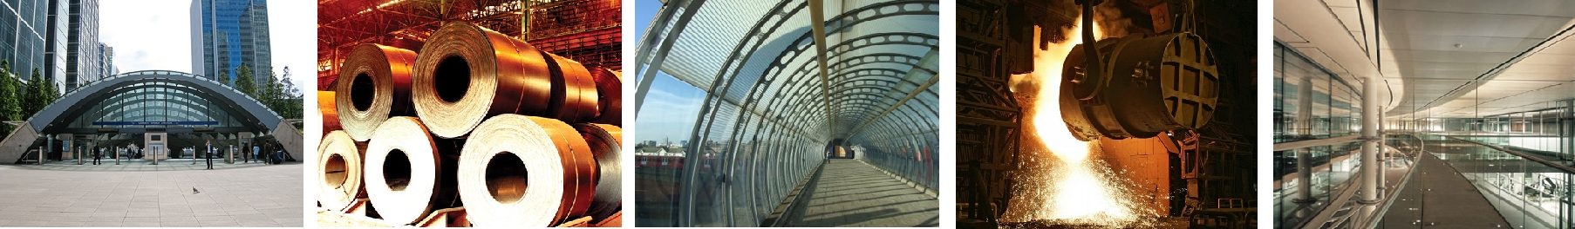

In Past Recessions, Companies Such As Chrysler Corp., Johnson& Johnson and Several

Units of General Electric Co. Have Improved Their Profitability, Productivity and Performance with the Rigorous, Systematic and Eﬃcient Use of Business Process Analysis, Activity Based Cost-Ing and Cycle Time Compression Metrics, Among Other Things. Accounting and Finance Execu-Tives in Winning Companies Have Built Career Lasting Reputations for Excellence by Leading Cost Leadership Initiatives with the Cooperation and Support of Their Business Partners.

Successful Cost-Leadership Initiatives Often Involve More Than a Singular Tool. Imagine Trying to Complete a Major Home Repair Project with a Limit of Just One Tool; It Would Be Virtu-Ally Impossible to Do. The Same Is True for Cost-Leadership Initiatives.

Surveys at a Variety of Companies in Various Industries Have Found That the Overall Repu - Tation of the Finance and Accounting Function and Leadership has Improved Materially in the Last Two Decades. Managers and Leaders in Product Development, Marketing, Manufacturing, Logistics, Distribution and Other Functions May Be More Open to What an Accounting or Finance Professionals Can Oﬀer with a View Toward Supporting Profitable Business Growth.

The Time May Be Ripe to Pursue Aggressive, Well-Planned and Sophisticated Cost-Leadership Initiatives. It Is of Paramount Importance to Lay a Strong Foundation for Success by Considering Many of the Behavioral, Measurement, Cultural and Communication Issues in the Planning Phase.

In His 1980 Classic Competitive Strategy: Techniques for Analyzing Industries and Competitors, Porter Simplifies the Scheme by Reducing It Down to the Three Best Strategies. They Are Cost Leadership, Diﬀerentiation, And Market Segmentation(Or Focus). Market Segmen-Tation Is Narrow in Scope While Both Cost Leadership Relatively Broad in Market Scope.

Cost Leadership Strategy

This Strategy Emphasizes Eﬃciency. By Producing High Volumes of Standardized Prod -

Ucts, The Firm Hopes to Take Advantage of Economies of Scale and Experience Curve Eﬀects. The Product Is Often a Basic No Frills Product That Is Produced at a Relatively Low Cost and Made Available to a Very Large Customer Base. Maintaining This Strategy Requires a Continuous Search for Cost Reductions in All Aspects of the Business. The Associated Distribution Strategy Is to Ob-Tain the Most Extensive Distribution Possible. Promotional Strategy Often Involves Trying to Make a Virtue Out of Low Cost Product Features.

To Be Successful, This Strategy Usually Requires a Considerable Market Share Advantage or Preferential Access to Raw Materials, Components, Labour, Or Some Other Important Input. Without One or More of These Advantages, The Strategy Can Easily Be Mimicked by Competitors. Successful Implementation Also Benefits From:

- Process Engineering Skills

- Products Designed for Ease of Manufacture

- Sustained Access to Inexpensive Capital

- Close Supervision of Labour

- Tight Cost Control

- Incentives Based On Quantitative Targets.

A Firm Attempts to Maintain a Low Cost Base by Controlling Production Costs, Increasing

Their Capacity Utilization, Controlling Material Supply or Product Distribution and Minimizing Other Costs Including R&D and Advertising. Mass Production, Mass Distribution, Economies of Scale, Technology, Product Design, Learning Curve Benefit, Work Force Dedicated for Low Cost Production, Reduced Sales Force, Less Spending On Marketing Will Further Help a Firm to Maintain Low Cost Base. Decision Makers in a Cost Leadership Firm Will Be Compelled to Closely Scrutinize the Cost Eﬃciency of the Processes of Thefirm. Maintaining the Low Cost Base Will Become the Primary Determinant of the Cost Leadership Strategy. For Low Cost Leadership to Be Eﬀective a Firm Should Have a Large Market Share. New Entrants or Firms with a Smaller Market Share May Not Benefit From Such Strategy Since Mass Production, Mass Distribution and Economies of Scale Will Not Make an Impact On Such Firms. Low Cost Leadership Becomes a Viable Strategy Only for Larger Firms. Market Leaders May Strengthen Their Positioning by Advantages Attained

Through Scale and Experience in a Low Cost Leadership Strategy. To Illustrate This We Are Looking at the Steel Sector and Specifically at Tata Steel As the Cost Leader.

Tata Steel

Tata Steel, India’s Largest Steel Company and the World’s Sixth-Largest by Capacity Is The

Cost Leader in the Steel Manufacturing Sector. Tata Steel Owns Raw Material Assets Such As Coal and Limestone Mines Through Joint Ventures or Completely, With the Assets Spread Across Coun-Tries Such As Australia, Oman and Mozambique. Tata Steel and State-Owned Sail Have Largely Been Able to Withstand Raw Material Price Fluctuations Due to Captive Iron Ore Mines. Tata Steel Is Also One of the Least Cost Markers of Steel in the World. Other Private Steel Companies, Hit by Steep Iron Ore and Coal Prices, Have Passed On the Hikes to the Customers, Prompting the Gov-Ernment to Clamp Down On Price Increases to Control Inflation.

Tata Steel, Which Bought Out Global Major Corus Last Year Doubled It's Profits Based On

The Acquisition. Tata Steel and Corus Together Sell More Than Two-Thirds of Their Production in Europe. The Consolidated Full Year Net Profit for Tata Steel Stood at Rs 12,321.76 Crore, Com-Pared to Rs 4,165.61 Crore, Due to Contribution From Corus Businesses. The Consolidated Reve-Nue for the Full Year Totaled Rs 1,32,110.09 Crore, Compared to Rs 25,650.45 Crore Last Year. Anglo-Dutch Steel Maker Corus Was Acquired in January Last Year for $13 Billion.

In 2006 Tata Steel Used to Produce 6.4 Million Metric Tonnes of Steel and Was Ranked

45th in the World by Capacity. In 2007 Post Acquisition of Corus It's Capacity Became 26.5 Mil-Lion Metric Tonnes and Was Ranked 6th in the World. Sail Is Ranked 19th in the List. The Other Companies Preceding Tata Steel Are Arcelor Mittal, Nippon Steel, Jfe, Posco and Bao Steel. However, While Most Other Companied Are Facing the Challenge of Low Margins, Tata Steel has Remained Positive Because of the Cost Leadership It Maintains. In the Iron and Steel Industry, The Prices Are Determined by the Market and Hence All That a Producer Can Do Is Cut Down On It's Costs Ti Sustain It's Margins.

Surprisingly, China Happens to Be the Highest Producer and Consumer of Iron and Steel

In Asia. It has Been Illustrated in the Pie Chart Below. This Presents Tata Steel with a Sea of Opportunities As the Highest Consumer of Steel in the World Is It's Neighbor.

The Key Factors That Work for Tata Steel Are As Follows

- Management Is Confident of Passing On to Customers the Impending Raw Material Cost In-Creases.

- Continuous Improvement Programs at Corus to Result in Savings/benefits of Gbp 300 Mn in Fy08. In Comparison the Fy09 Savings/benefits Is Usd 350 Mn.

- Regards the Total Acquisition Synergy Benefits of Usd 450 Mn, A Run Rate of 30% (Usd 135 Mn) Has Already Been Achieved.
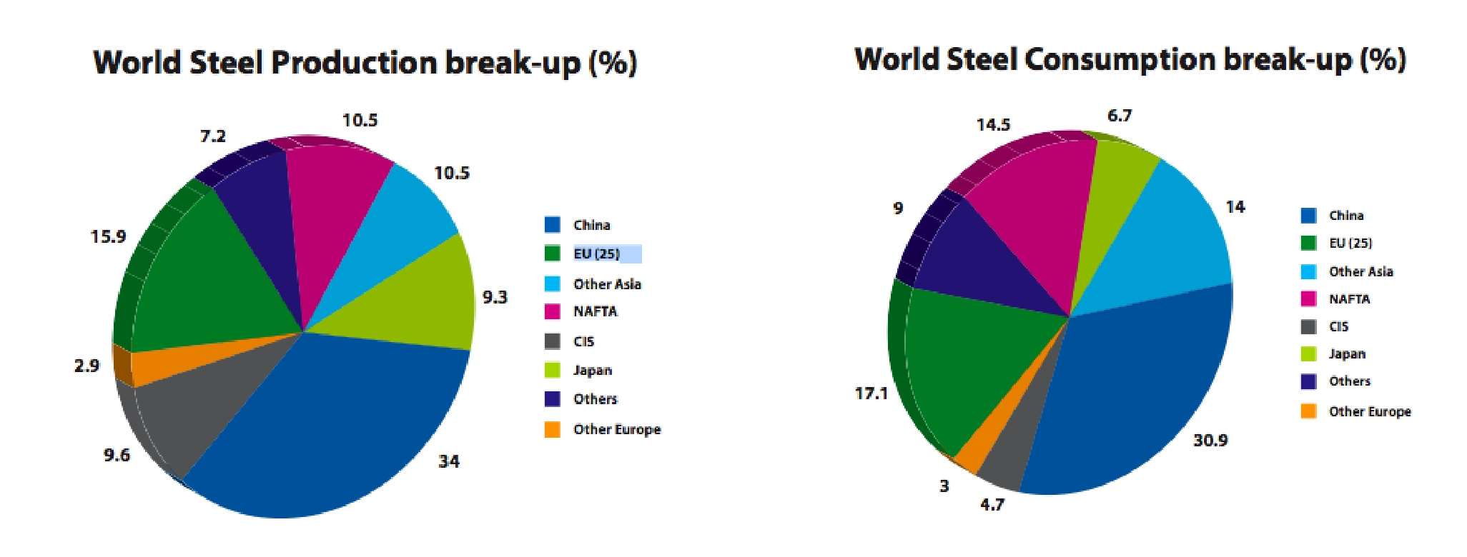

Key Data On the Steel Industry

India Is Among the Least Cost Producers of Steel and It Is Reflected in the Graph Below:
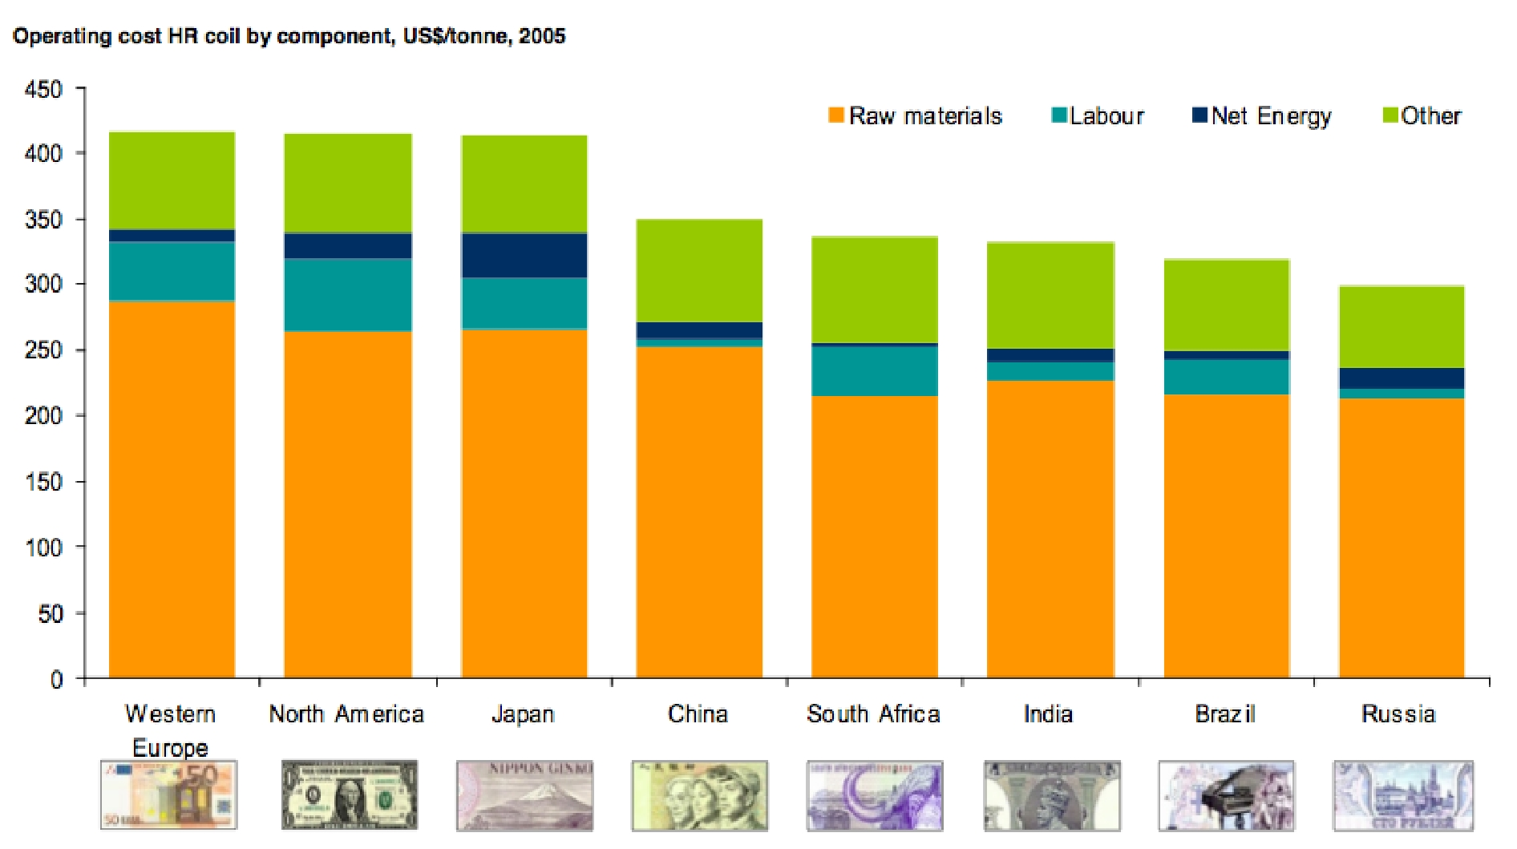

Cost of Raw Material in India Is Much Cheaper When Compared to Other Countries; Specially China. As We Can See in the Figure Below, India Is Among the Cheapest Countries to Source Steel.
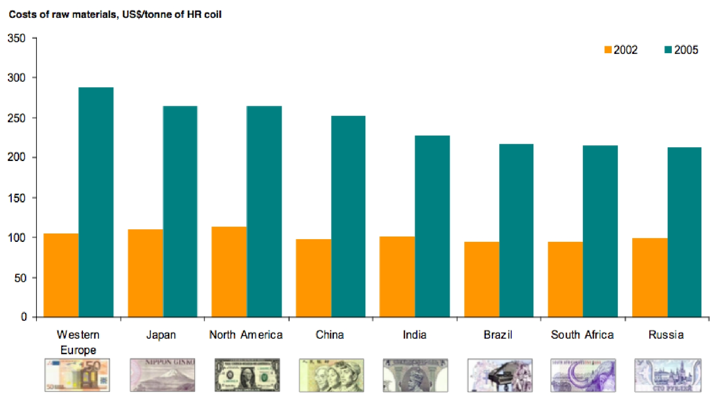

India Also has the Cheapest Labour Costs for a Company. Although, Brazil and South Africa

Have Cheaper Raw Material Cost, They Have a Higher Labour Cost to Compensate. Tata Steel has Access to One of the Cheap-Est Labour Markets and Hence Is in a Very Strong Position in Minimizing It's Cost of Production. How-Ever, It Must Be Noted That Indian Labourers Are Not the Most Efficient of La-Bourers. They Are Much Below the World Average When It Comes to Eﬃciency.
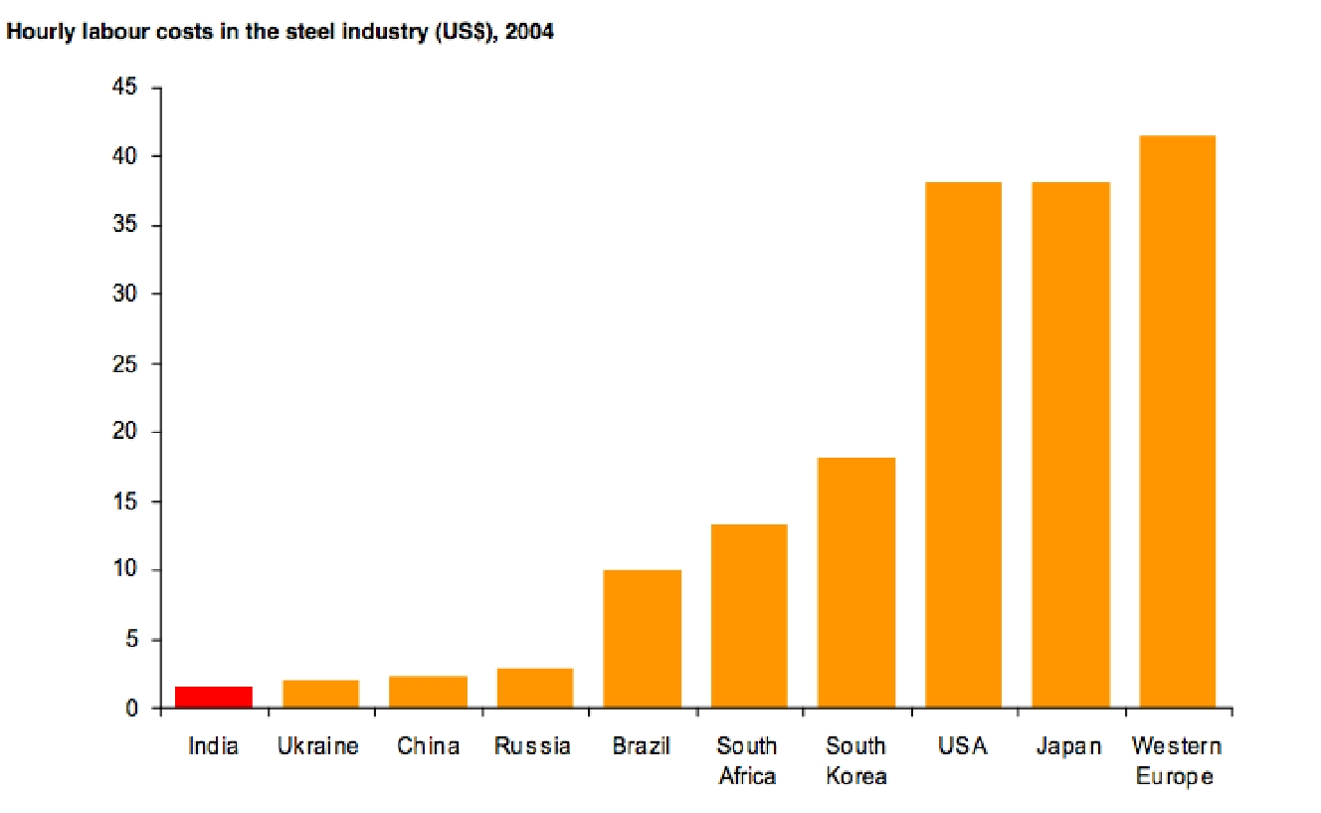

As the Industry Data Suggests, Indian Workers Are Not the Most Eﬃcient Among Workers. Tata Steel in Comparison Pays a Heavy Sum When Compared to It's Com-Petitors. However, With the Ac-Quisition of Corus, It Is Bound to Improve As Corus has One of the Most Eﬃcient Workforces. Japanese Nippon Steel and Ko-Rean Posco Rule the Roost When It Comes to Productivity.
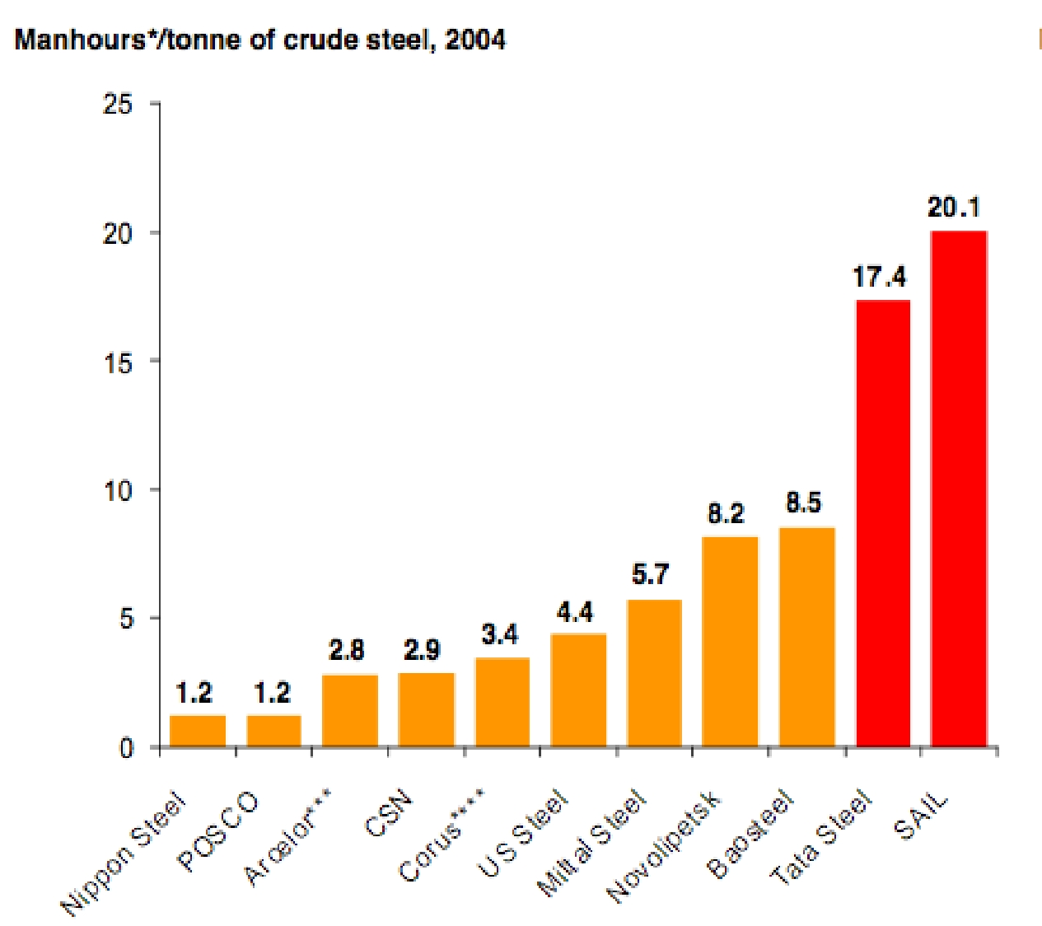
If Only Tata Steel Can Improve Upon Employee Pro-Ductivity, It Can Further Cut It's Costs to a Certain Extent. It Must However Be Noted That Labour Cost Accounts to Only to 7-8 % Of Tata Steel’s Revenues and Hence May Not Hold Too Much of Relevance As Yet. But As the Times Goes, It Is Bound to Be An
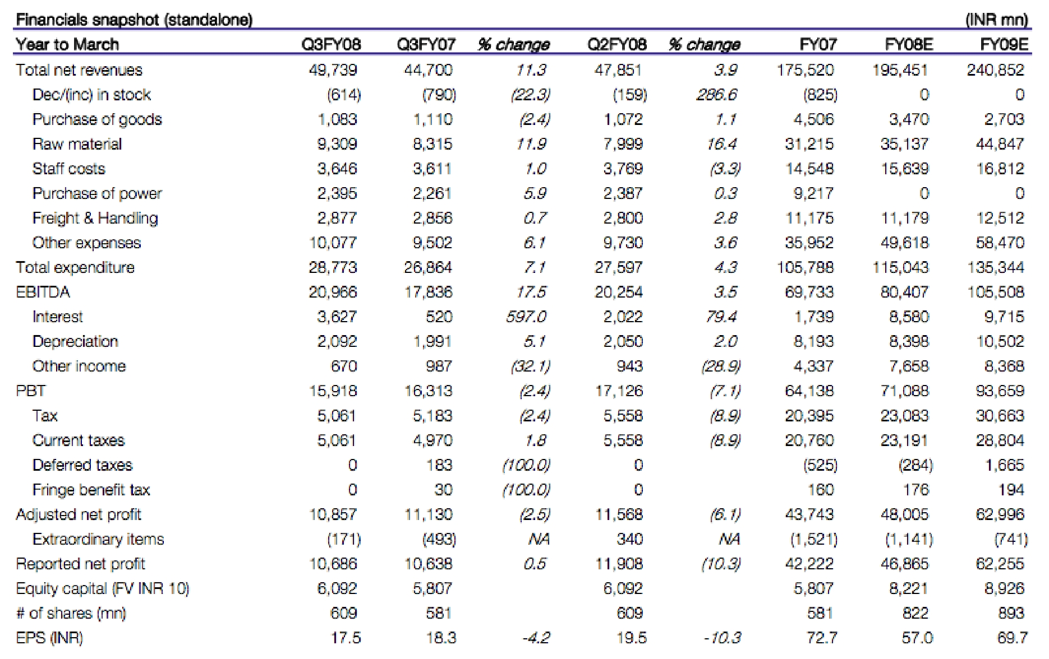

Issue and Must Be Checked Immediately. The Data On Cost As a Percentage of Revenues Is Given Below.
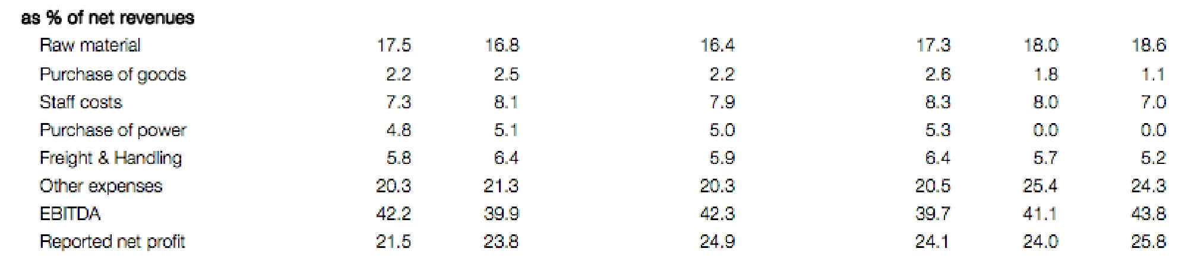

Furthermore, Tata Steel Also has a High Return On Investment and Capital Employed Which Is Furnished Below:
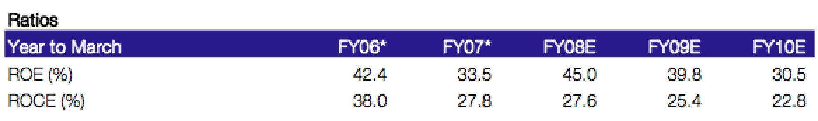

Although It has Been Declining, It Is Expected Since the World Steel Prices Have Taken a Beating Since the Economic Crisis Came Into the Picture.

As We Can See in the Graph Below, India has the Competitive Advantage in Labour Beating All Countries Including China.
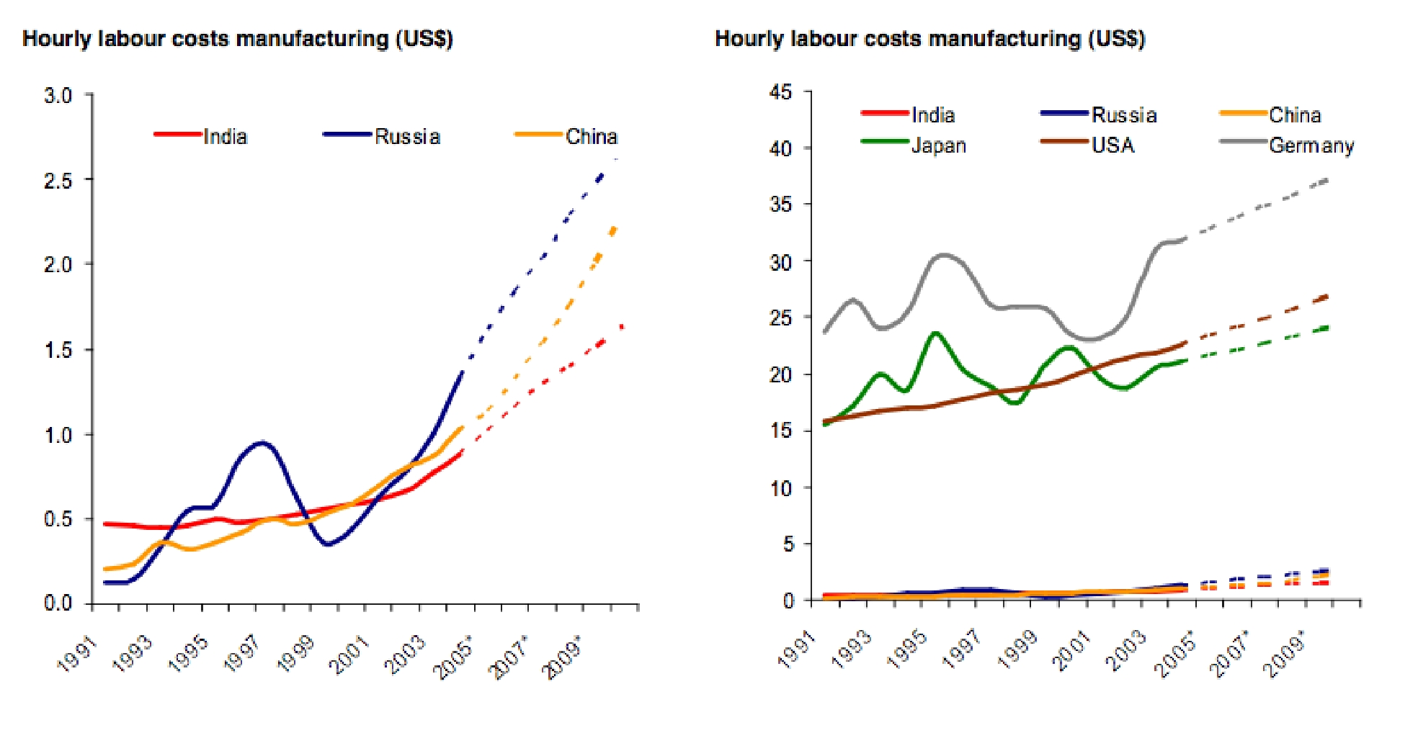

According to Tata Steel Estimates, It’s Operating Margins Will Still Remain Close to 20% Despite the Global Slowdown. The Ebitda of 17% For Both 2009-10 Indicates Why It Pays to Be the Cost Leader. The Balance Sheets of Both Nippon Steel and Posco Would Indicate That
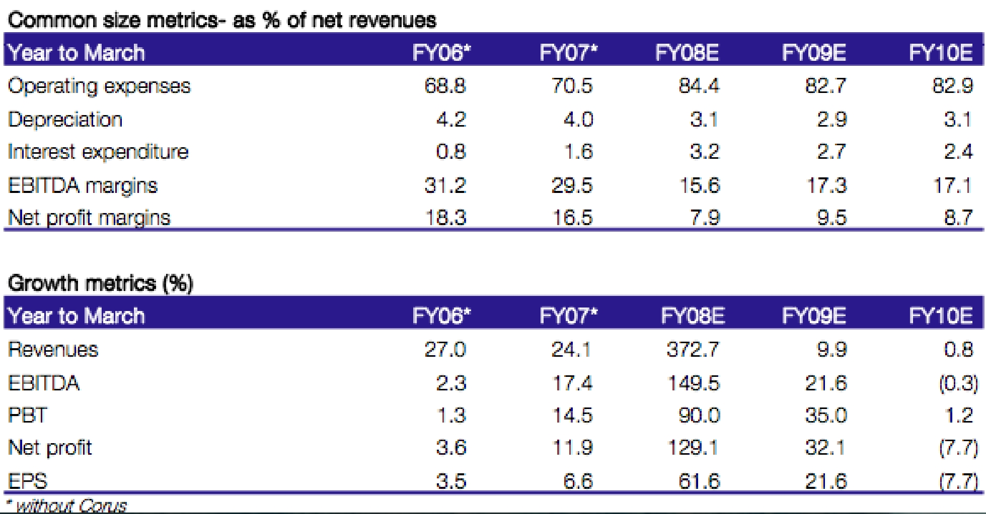

They Have Cut Production to Brace for the Coming Recession. However, The Standalone Data of Tata Steel During the Period has Shown an Increase of 20%. (Source: Tata, Nippon, Posco Annual Reports)
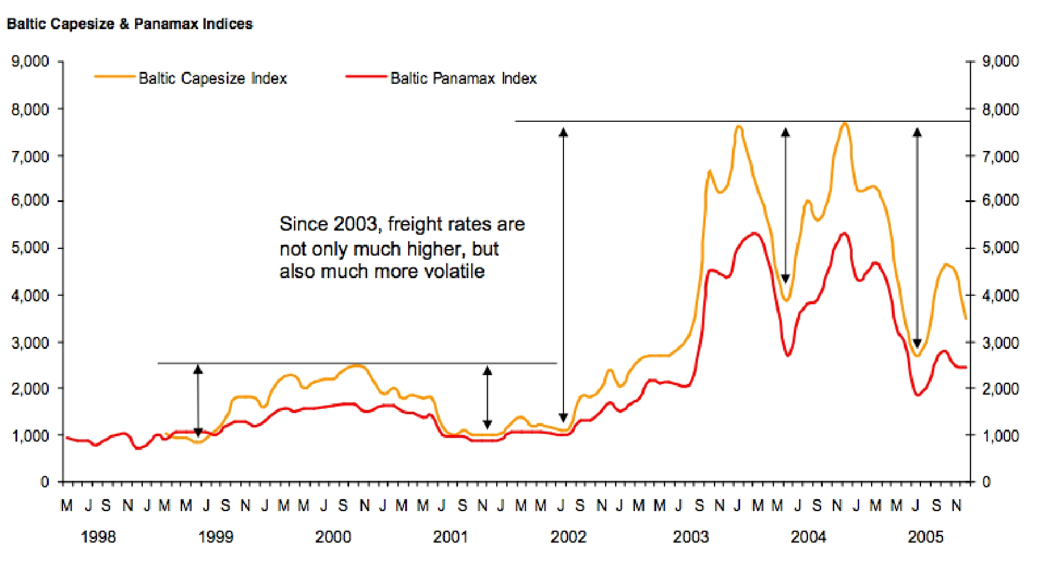

Another Important Factor Adding to the Operating Expenses of the Company Includes Transpor-Tation and Freight Charges. Since Tata Steel has to Source It's Raw Materials From Many Points Such As Australia and Africa, Freight Becomes a Major Component of of It's Cost. Also, It has Production Facilities in Multiple Locations and Sourcing Becomes a Important Concern. It has Been Observed That These Have Been On the Rise yet Have Been Volatile. To Neutralize This Eﬀect Superior Cost Control in the Areas Where It Possible Is Highly Important. While On One Hand, There Are Uncontrollable Costs, It Is the Controllable Costs That the Company Must Aim to Cut Back On. In This Area, Tata Steel has Been Highly Successful.

Organizing to Implement a Cost Leadership Strategy Requires Particular Consideration To

The Organizational Structure, Management Controls, Compensation Policies, And Implementing Cost Leadership Strategies. The Organizational Arrangements and Implementation Tools Should Not Only Fit but Reinforce the Strategy. Porter (1980) Has Divided Requirements of Overall Cost Leadership Strategy Into “commonly Required Skills and Resources” And “common Organiza-Tional Requirements”. Commonly Required Skills and Resources When Implementing Overall Cost Leadership Are Sustained Capital Investment and Access to Capital, Process Engineering Skills, In-Tense Supervision of Labor, Products Designed for Ease in Manufacture, And Low-Cost Distribu-Tion Systems. Common Organizational Requirements Constitute of Tight Cost Control, Frequent, Detailed Control Reports, Structured Organization and Responsibilities, And Incentives Based On Meeting Strict Quantitative Targets. According to Barney & Hesterley (2006), Few Layers in the Reporting Structure, Simple Reporting Relationships, Small Corporate Staﬀ, And Focus On Narrow Range of Business Functions Are Elements of Organizational Structure That Allow Firms to “realize the Full Potential of Cost Leadership Strategies”. Management Control Systems That Support the Implementation of Cost Leadership Include Tight Cost Control Systems, Quantitative Cost Goals, Close Supervision of Labor, Raw Materials, Inventory, And Other Costs, And a Cost Leadership Phi-Losophy. Examples of Good Compensation Policies Are Rewards for Cost Reduction and Incentives for All Employees to Be Involved in Cost Reductions.

With the Example of Tata Steel, We Can See How a Cost Leadership Strategy Can Serve a Company in Good Stead. As We See Companies Like Nippon Steel Are Crumbling Under the Weight of Their Size and Are Taking Cover Trying to Improve Their Margins by Cutting Down Staﬀ And so On. On the Other Hand a Strict Cost Control Program has Resulted in Good Returns to Tata Even in Recessionary Periods.

Cost Leadership at Reliance Industries

In the 2005 Annual General Meeting It has Been Stated That Reliance has Become a Global Leader in Various Business Activities Based On Innovation and Cost Leadership (Reliance Industries Limited, 2007). Reliance Today Enjoys a 7 % Global Market Share in the Textile Poly-Ester Business. India, China and South East Asia Have Nearly 80% Of Global Textile Polyester Capacity, Along with Presence in Downstream Textiles. Reliance Commissioned a 730,000 Tonnes Per Year Pta Plant at Hazira. This Makes Reliance the Fourth Largest Producer of Pta in the World.
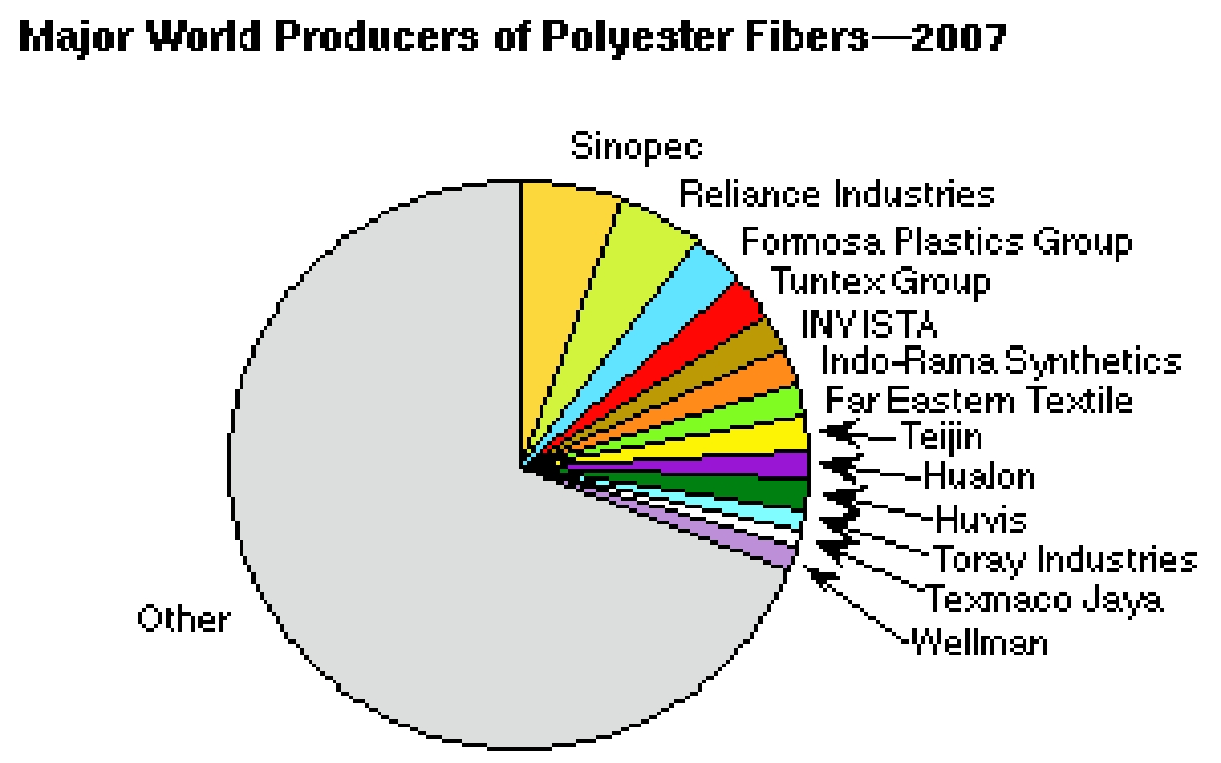

Low Costs Are Achieved in Two Ways: (Blacksacademy, N.D)

- More Eﬃcient Production Arising From Experience: Reliance has Been in This Industry Since 1977 And Thus the Experience Lead Them to Find More Eﬃcient Methods of Production. The Polyester Manufacturing Is a Complicated/technical Process Thus Reliance Have a Competi-Tive Advantage As the Experience Advantage Will Be Greater and Diﬃcult to Capture in Short Term.

- Economies of Scale: Reliance Is the Global Leader and Thus Due to High Demand and Produc-Tion Lead the Company to Have Eﬃcient Size of Plant, Management Structure and so Forth. Reliance Being a Global Player Have Enough Sales to Justify Investing in Additional Capacity to Capture Economies of Scale.Reliance Will Also Have a Cost Advantage Because Competitors May Not Be Able to Match the Scale Because of Capital Requirements (Barrier to Entry) As the Firm Works in Many Countries and Across the International Borders.

- Through Innovation in Production Methods, Leading to New Techniques of Production or Better Organization of Production: Reliance Always Believed in Innovation and Introduced Many New Methods Into the Indian Industry of Polyester.

- Plentiful Source of Low Cost Labor: Reliance has It's Manufacturing Units and Head Oﬃce in India Which Helped the Company to Have a Plenty of Raw Material and Skilled Labour at Low-Est Cost.

- Diﬀerential Low-Cost Access to Productive Inputs: Reliance has Been Founded by Dhiru Bhai Ambani Which Gave the Firm Cost Advantage Over the Others Because He Introduced/ Pioneered the New Polyester Manufacturing in India

The Benefits of Low Cost Strategy Are:

- The Cost Leadership Helps the Reliance to Survive in the Price War Against It's Competitors.

- Supernormal Profits Generated From Increase in Market Share and Demand Helps Reliance Group to Reinvest Some Funds Into Their Internal Business Activities to Improve Quality and Continue Cutting Costs.
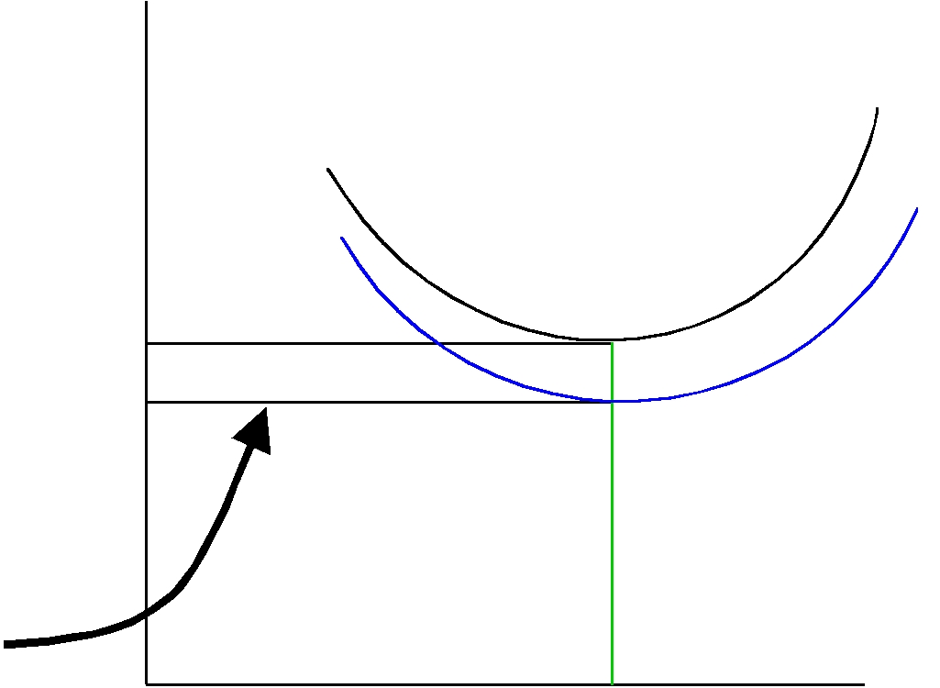
^{Atcind}

Atcff

P |  | D

Above Normal

Economic Returns or Super
Normal Profits

Q

Risks Associated with Low Cost Strategy Are:

- Over-Emphasis On Costs Makes Reliance Group Inward Looking, Production Orientated and Poorly Focused On Customer Needs.

- There Can Only Be One Lowest Cost Producer in the Industry.

- Gains to Be Made Through Learning- I.E. Through More Eﬃcient Production Are Usually Minimal and the Most Eﬃcient Scale of the Plant Can Be Copied. That Is "Many Routes to a Low Cost Position Can Be Easily Copied."

- If Reliance’s Competitors Have Other Profitable Products, Then Being a Lowest Cost Producer Is Not Enough to Survive the Price War: Competitors Can Cover Their Fixed Cost with Profit From the Other Lines and Price Close to What the Variable Cots Are.

Due to Above Risks As Mentioned We Would Recommend the Company to Not Fully De - Pend On Cost Leadership. Reliance Should Invest Ion R&D to Keep Innovating It's Product and Oﬀer Variety to Customers.

Polyester Margin Environment

( Http://www.Ril.Com/rportal1/downloadlibuploads/1210924385906 Ar0708r.Pdf)

Cotton, The Second Largest Fibre in Demand, Is Witnessing a Firm Trend in Prices. Falling Stocks Accompanied by Declining Acreage has Increased Prices of Cotton by More Than 26% In the Previous Year. Global Quest for Bio-Fuels Is Impacting the Agriculture Economies World-Wide. In February 2008, Cotton Futures for May 2009 Went Up to As High As 97 Cents Per Pound ($ 2,138/ Tonne) Showing Signs of Firm Undertone. This Is One of the Highest Levels in the Last Decade.
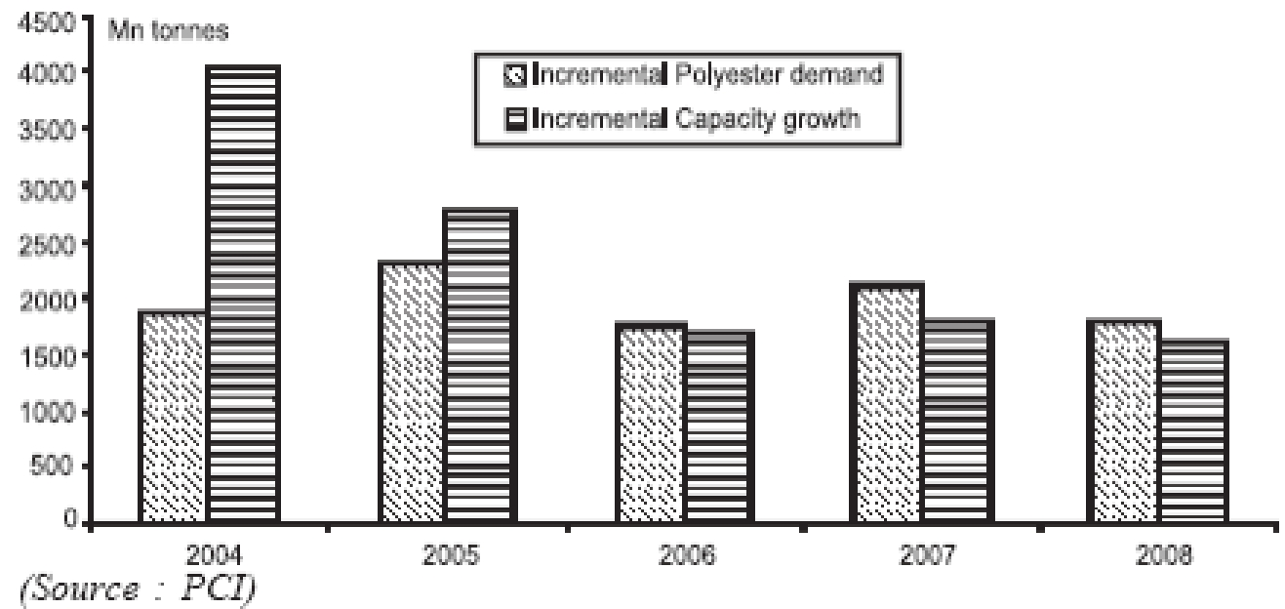

The United States, The World’s Third Largest Cotton Producer, Has Seen a 28% Fall in Acre - Age Under Cotton Production for Current Season (2007-08) And Is Likely to See a Further Drop in the Years to Come. Most of the Farmers Have Shifted to Planting of Corn and Soybean, Due to Robust Demand From the Bio-Fuel Industry. Due to Rapid Additions in Polyester Capacity in China, There has Been Over-Supply Since 2000. Low Margins in the Last Few Years Have Reduced Incremental Growth in Polyester Capacities in Countries Like China. From an Incremental Capac-Ity of 2 Million Tonnes Over Incremental Demand in 2004, Currently Incremental Demand Is More Than the Annual New Capacity Creation.

Polyester Consumption Is Growing Faster Than That of Any Other Fibre. There Are Large Pockets of Population That Have Low Consumption Like the Indian Sub-Continent and Africa. While the Global Per Capita Demand for All Fibre Stands at 11 Kgs, With China at 16 Kgs and the Us at 38 Kgs, India Is Still at Less Than 5 Kgs and Africa Is at Less Than 4 Kgs. These Regions Con-Tribute to Nearly Half of the World’s Population and Are Witnessing Increase in Disposable In-Come with Overall Economic Prosperity. Historically It Is Seen That Rising Per Capita Income and Industrialization Increase Textile Consumption for Both Apparel and Non-Apparel Applications. Due to Inherent Constraints in Growth of Cotton, Polyester Is Likely to Capture the Maximum Share of Future Growth.

The Domestic Scenario

Currency Appreciation has Been of Major Concern for Textile Exporters in India. Last

Year, The Indian Rupee has Appreciated Against Us Dollar by 7.7%. Textile Exports Being a Highly Competitive Business, Is Adversely Aﬀected by an Appreciating Rupee. The Indian Government Reduced the Import Duty On Polyester From 10% To 7.5% And Again to 5% Mid Year in Novem-Ber 2007. The Government, In an Eﬀort to Give a Fillip to Investments in Downstream Textile Industry has Extended Textile Up-Gradation Fund in the 11th Five Year Plan. Benefits of This Fund Have Been Extended to Technical Textiles, Which Is an Under-Penetrated Segment for Indus-Trial and Household Polyester Applications. With a Growing Presence in Domestic Textile Growth Segments Like Non-Woven, Industrial and Automotive Yarns, Reliance Is Well Positioned to In-Crease It's Polyester Market Share Over Other Indian Manufacturers.

Domestic Demand

Polyester Witnessed Exciting Demand Growth in the Domestic Market at 17% Over the Previous Year. Poy Demand Grew by 18% Whereas Psf Demand Grew by 12%. The Increased Demand for Polyester Was Driven by Robust Investments in Textile Sector and Pet Consuming Industries During the Previous Year.

Touching 28 Touching Lives. Transforming India. Indian Pet Bottle Resin Market Grew By

26% And Is Expected to Sustain the Growth Rate Due to a Wider Scope of Increased Penetration in Carbonated Soft Drink, Mineral Water, Fruit Juice, And Healthcare and Agro-Chemicals Seg-Ments. Reliance, With a Share of 55% In Pet Market, Is the Largest Player in the Country. Pro-Duction Volumes of the Polyester (Pfy, Psf and Pet) Including Trevira and Recron Malaysia, Increased by 16.6% To 1,910 Kt. Production From the New Domestic Polyester Facility has Been Placed Successfully in the Market. The Company has Maintained It's Focus On Specialty Products Which Account for 54% And 38% Of Psf and Pfy Production Respectively. Reliance’s Domestic Market Share Is Now in Excess of 49%.

New Product Initiatives

- Copol & Copol Blended Fabrics.

- Polyester / Wool / Bamboo Blended Fabrics with Inherent Antimicrobial, Anti-Odor and Uv Protection Properties.

- Wool / Soya Blended Fabrics with Having Similar Moisture Absorption Capabilities As Cotton.

- Durable Moisture Management in 100% Polyester Sports Wear Fabrics.

- Fire-Retardant and Water Proof Tent Fabric, Providing Additional Safety From Fire Hazards.

- Water and Oil Repellant Fabrics Made From Eco-Friendly Recycled Polyester.

With Continuous Improvements and Extensive Backward Integration, Reliance Stands Out As the Cost Leader in It's Industry. However, It Is Important for Both Tata Steel and Reliance Indus-Tries Ltd. To Look at Sustaining It's Cost Leadership Over the Years to Come. With Eﬀective In-Volvement of Cost Control, There Is Further Scope for Cutting Down On Costs and Remaining the Undisputed Cost Leader in It's Segment. Considering the Present Recessionary Phase All Over the World, Cost Leadership Will Stand Out As the Single Biggest Recipe for Success.

Bibliography

Author Last Name, First Name. “book Title or Ref-Erence Title.” City: Publisher, Date.

Webster, Williams. Cpa. Accounting for Managers, Mc Graw Hill, 2005

Porter,. E. Michael. Competitive Strategy, Free Press, 1980

Grant,.M. Robert. Contemporary Strategy Analysis, Black-Well Publishing, (Wiley), Fifth Edition, 2007

Homgren, Charles. Datar, Srikanth. Foster, George. Cost Accounting. Pearson Prentice Hall, 2005

Website Urls:

Www.Allbusiness.Com

Www.Tatasteel.Com

Www.Posco.Com

Www.Nsc.Co.Jp

Www.Worldsteel.Org

Www.Ril.Com

Www.Sriconsulting.Com

Annual Reports:

Annual Reports- Tata Corus

Annual Report- Nippon Steel

Annual Report- Arcelor Mittal

Annual Report- Posco

Annual Report- Reliance Industries

Reports:

India Equity Research, Metals and Mining, By Edelweiss November 2008

Cost Leaders in the New World, Steel Consult International

Report On the Polyester Industry: Blacks Academy

More Free Term Papers On Site: Www.Maturski.Org

